20272 VETERANS DRIVE • ELKHORN, NE 68022
PRESS RELEASE
PRESS RELEASE
Contact: Stacey L. Falk, Executive Director FOR IMMEDIATE RELEASE
Elkhorn Public Schools Foundation November 5, 2018
402-289-1727 • sfalk@elkhornfoundation.org
www.elkhornfoundation.org

ELKHORN PUBLIC SCHOOLS FOUNDATION HOSTS HALL OF FAME RECEPTION & AWARDS CEREMONY

Elkhorn, NE - For 35 years, The Elkhorn Public Schools Foundation has been dedicated to enriching education and providing opportunities for students in the Elkhorn Public Schools District. In addition to funding classroom grants for students of all age levels and awarding scholarships to graduating seniors, the Elkhorn Public Schools Foundation honors educators, community members and businesses at its Annual Hall of Fame Reception. This year, the Foundation was thrilled to host its 24th Annual event in the brand new Elkhorn Alumni Center located in the lower level of the Foundation’s office building. On October 25th, over 200 guests were in attendance when the Foundation inducted 10 educators, support staff members, volunteers, alumni, and community boosters into its Hall of Fame. Foundation Board President, Paul Baumert welcomed guests, followed by Elkhorn High School student Susann Parlor singing the National Anthem. Guests were treated to heavy hors d’ouevres from Sam & Louie’s Catering and assorted desserts from Matt Edwards Fine Foods. “It was a beautiful fall evening as we celebrated with Elkhorn families of all ages, honoring so many deserving recipients. The many accomplishments shared about each recipient and the supportive guests in attendance was a testament to the amazing Elkhorn community we live in and the outstanding Elkhorn Public Schools family,” said Stacey Falk, Executive Director of the Elkhorn Public Schools Foundation.

During the Awards Ceremony, the Foundation inducted 10 members into its Hall of Fame. The Carl L. White Outstanding Educator of the Year, presented to an outstanding administrator or teacher who has been with the district more than 5 years, was awarded to Melissa Mehlmann. Melissa has spent her entire teaching career with Elkhorn Public Schools. Melissa has taught at Westridge Elementary, Fire Ridge Elementary and currently teaches fifth grade at HIllrise Elementary. Nebraska Orthopaedic Physical Therapy was recognized as the Community Booster of the Year. Nebraska Orthopaedic is a new business to the community, who since opening its doors at its Elkhorn facility has sponsored scholarships for Elkhorn Public Schools’ seniors and has volunteered at various community events. Former Educator of the Year was awarded to Charles Rohlfing who was with the Elkhorn Public School District for 27 years, serving as counselor and high school principal. Dr. Kyle Ringenberg, Elkhorn High School Class of 1998, and Dr. Brenda ‘Barth’ Roman, Elkhorn High School Class of 1980, were recognized as the Alumni of the Year for their successful medical careers. Dr. Ringenberg currently serves as the Director of Liver Transplant Anesthesia with UNMC. He has also developed Enhanced Recovery After Surgery programs, taken part in multiple international medical trips and serves on the UNMC College of Medicine Admissions Committee. Dr. Roman currently serves as the Associate Dean for Medical Education at Wright State University Boonshoft School (BSOM) in Dayton, Ohio. Dr. Roman led the transformation of teaching medicine at BSOM to a ‘lectureless’ curriculum, the first medical school in the nation to utilize entirely flipped classroom models of learning, including team-based learning and peer instruction. She is also a Distinguished Fellow of the American Psychiatric Association and a member of the Alpha Omega Alpha Medical Honor Society.

Molly Gonring of Elkhorn South High School (ESHS) was honored as the Golden Apple Outstanding Educator of the Year. This award is granted to an outstanding administrator or teacher who has been with the Elkhorn Public Schools District for five years or less. Molly is in her third year with ESHS, and co-teaches the curricular choirs and directs Shock Wave (women’s show choir), Power Surge (mixed-prep show choir) and the Spring Musical. The Partners in Education Mentor of the Year award was presented to Becky Hayworth who has made notable differences in the education and life experiences of Manchester Elementary students. Stacy Dryak was awarded one of two Support Staff Members of the Year awards for her dedicated SPED teaching assistant responsibilities at Sagewood Elementary. Linda Lamb was also awarded the Support Staff Member of the Year award for her 16 years dedicated as a teacher’s assistant in the district, most recently with Arbor View Elementary. Katy Bode was recognized as the Volunteer of the Year for numerous volunteer endeavors, not only with West Bay Elementary, but for her active role in the the community as a whole.

On behalf of the Foundation, Stacey Falk awarded a check to the Elkhorn Public Schools District for over $111,000 to fund classroom grants for the 2018-2019 school year. Each school will receive a customized version of this check showing the amount awarded to that school and a listing of the businesses, families, and fundraisers that donated to the Foundation’s Grant A Wish campaign.

If you would like more information about how to nominate individuals for the Foundation’s Hall of Fame, or how to contribute to the Foundation’s many programs, please contact Stacey Falk at 402.289.1727.

# # #

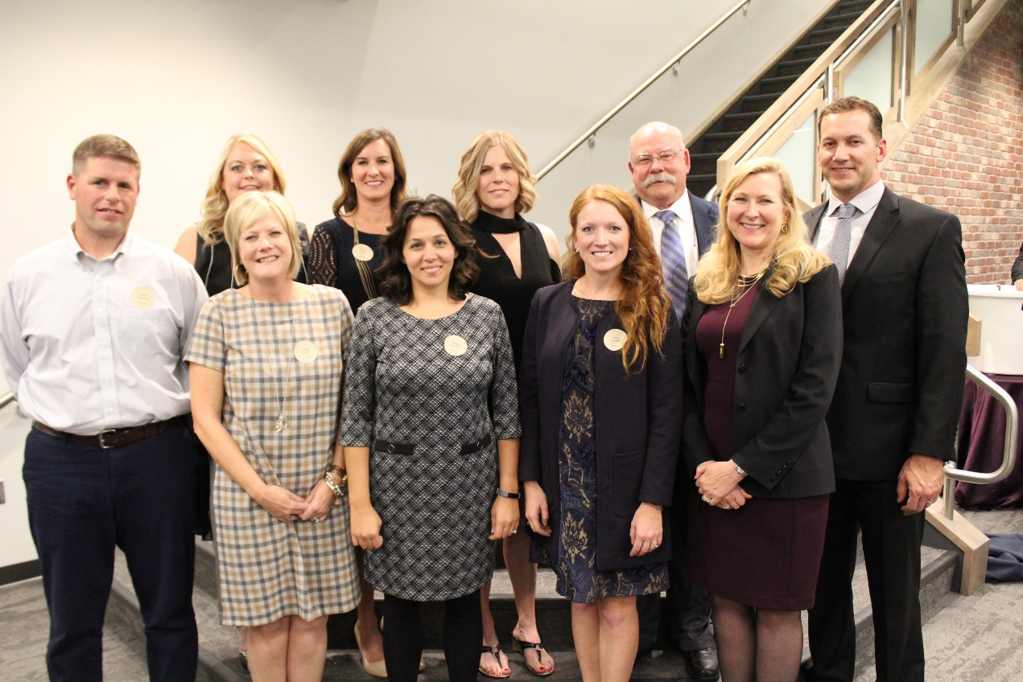

Photo #1 Caption: 2018 Hall of Fame Award Recipients. Back row (l-r): Stacy Dryak, Katy Bode, Becky Hayworth, Charles Rohlfing and Dr. Kyle Ringenberg. Front row (l-r): Ross Tessendorf, Linda Lamb, Melissa Mehlmann, Molly Gonring and Dr. Brenda ‘Barth’ Roman.

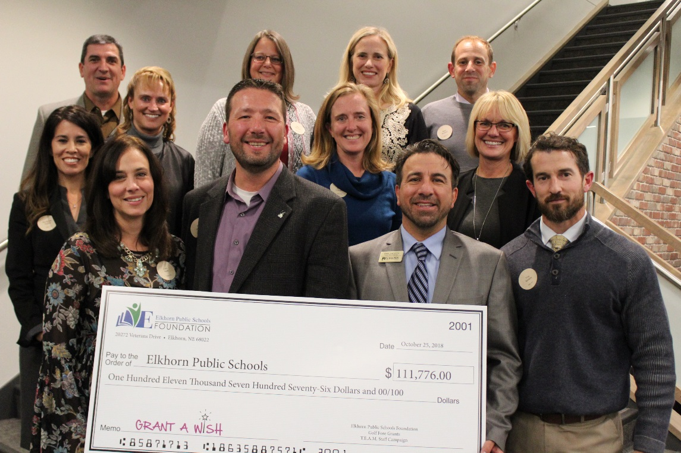

Photo #2 Caption: Elkhorn Public Schools representatives accepted a check for $111,000 for classroom grants from the Foundation at the Hall of Fame Reception. Each school will display a check highlighting the amount received and thanking their donors. Pictured in the back row above are Mike Tomjack (Elkhorn Grandview Middle School), Laurinda Petersen (Spring Ridge Elementary), Deb Garrison (Elkhorn Middle School), Amy Christ (Blue Sage Elementary School) and Ryan Broshar (Westridge Elementary School). Pictured middle row are Montessa Muñoz (Hillrise Elementary), Jen Coltvet (West Bay Elementary) and Jan Peterson (Sagewood Elementary). Pictured front row are Pam Wahl (West Dodge Station Elementary), Mark Kalvoda (Elkhorn South High School), Dan Radicia (Elkhorn High School) and Troy Sidders (Arbor View Elementary).

