20214 VETERANS DRIVE, STE. 400 • ELKHORN, NE 68022
PRESS RELEASE
PRESS RELEASE
Contact: Stacey L. Falk, Executive Director FOR IMMEDIATE RELEASE
Elkhorn Public Schools Foundation November 1, 2018
402-289-1727 • sfalk@elkhornfoundation.org
www.elkhornfoundation.org

Elkhorn Public Schools Foundation & Elkhorn soccer club hold 2nd annual 5k run

Elkhorn, NE - The Elkhorn Public Schools Foundation, in partnership with the Elkhorn Soccer Club, held their 2nd Annual 5K Run on Saturday, September 22nd. Close to 125 participants signed up for the 5K race and 100 yard Kids Dash. Prior to the race, 30 kids ran across the Elkhorn High School football field for the 100 yard Kids Dash. There were 95 runners signed up to run the 5K race which was professionally timed by Black Squirrel Timing. The 5K cross country style course began and ended in the Elkhorn High School football stadium. After the race, participants received bagels from Panera, bananas from Johnson Snack Supply and water from Hy-Vee (156th & Maple). Medals were given to the top 3 overall winners, as well as the top 3 in 6 different age brackets. Spencer Stednitz claimed the overall title, with Shane Lippold placing second and Andy Kamin coming in third.

More than just a morning of fun activity, it was an important event to benefit special education programs for Elkhorn youth. Event proceeds will fund both the Elkhorn Soccer Club’s High 5 Program and the Foundation’s Special Education Grant program in the Elkhorn Public Schools District. The Soccer Club’s High 5 Program was created through funds raised from the 1st Annual 5K Run. It delivers innovative curriculum designed for players who, for physical, mental or emotional reasons, cannot commit to a conventionally structured soccer competition. The program addresses 5 key components/skills: motor, social, sensory, emotional & soccer. The Foundation’s Special Education Grant program funds requests from Elkhorn Special Education teachers in the district for items such as thematic language and cross-curricular activities, equipment for sensory processing needs, special education iPads, toys for play skills therapy and much more!

Net proceeds from the 5K Run increased 400% from last year! This event would not have been possible without support from the community. Players from the men’s & women’s Nebraska Christian College soccer teams directed runners along the course. Numerous local businesses generously sponsored the event. Elkhorn Training Camp was this year’s Platinum Sponsor. Nebraska Realty, Brain Balance, Coerver Coaching, Nebraska Realty and CHI Health Lakeside were Gold sponsors. Fifteen other local businesses were Silver & Bronze sponsors of the event. “It was a wonderful morning for an incredibly noble cause. So many community members and their families came out to support our 2nd Annual 5K Run. This fundraiser immensely supports our special education children here in Elkhorn. Whether you ran, walked or were a sponsor, you were helping to make an impact, and for that we are extremely grateful for your generosity” stated Stacey L. Falk, Executive Director of the Elkhorn Public Schools Foundation.

To view photos from the 2018 5K event, or to learn more about upcoming Foundation events, please visit www.elkhornfoundation.org.
# # #

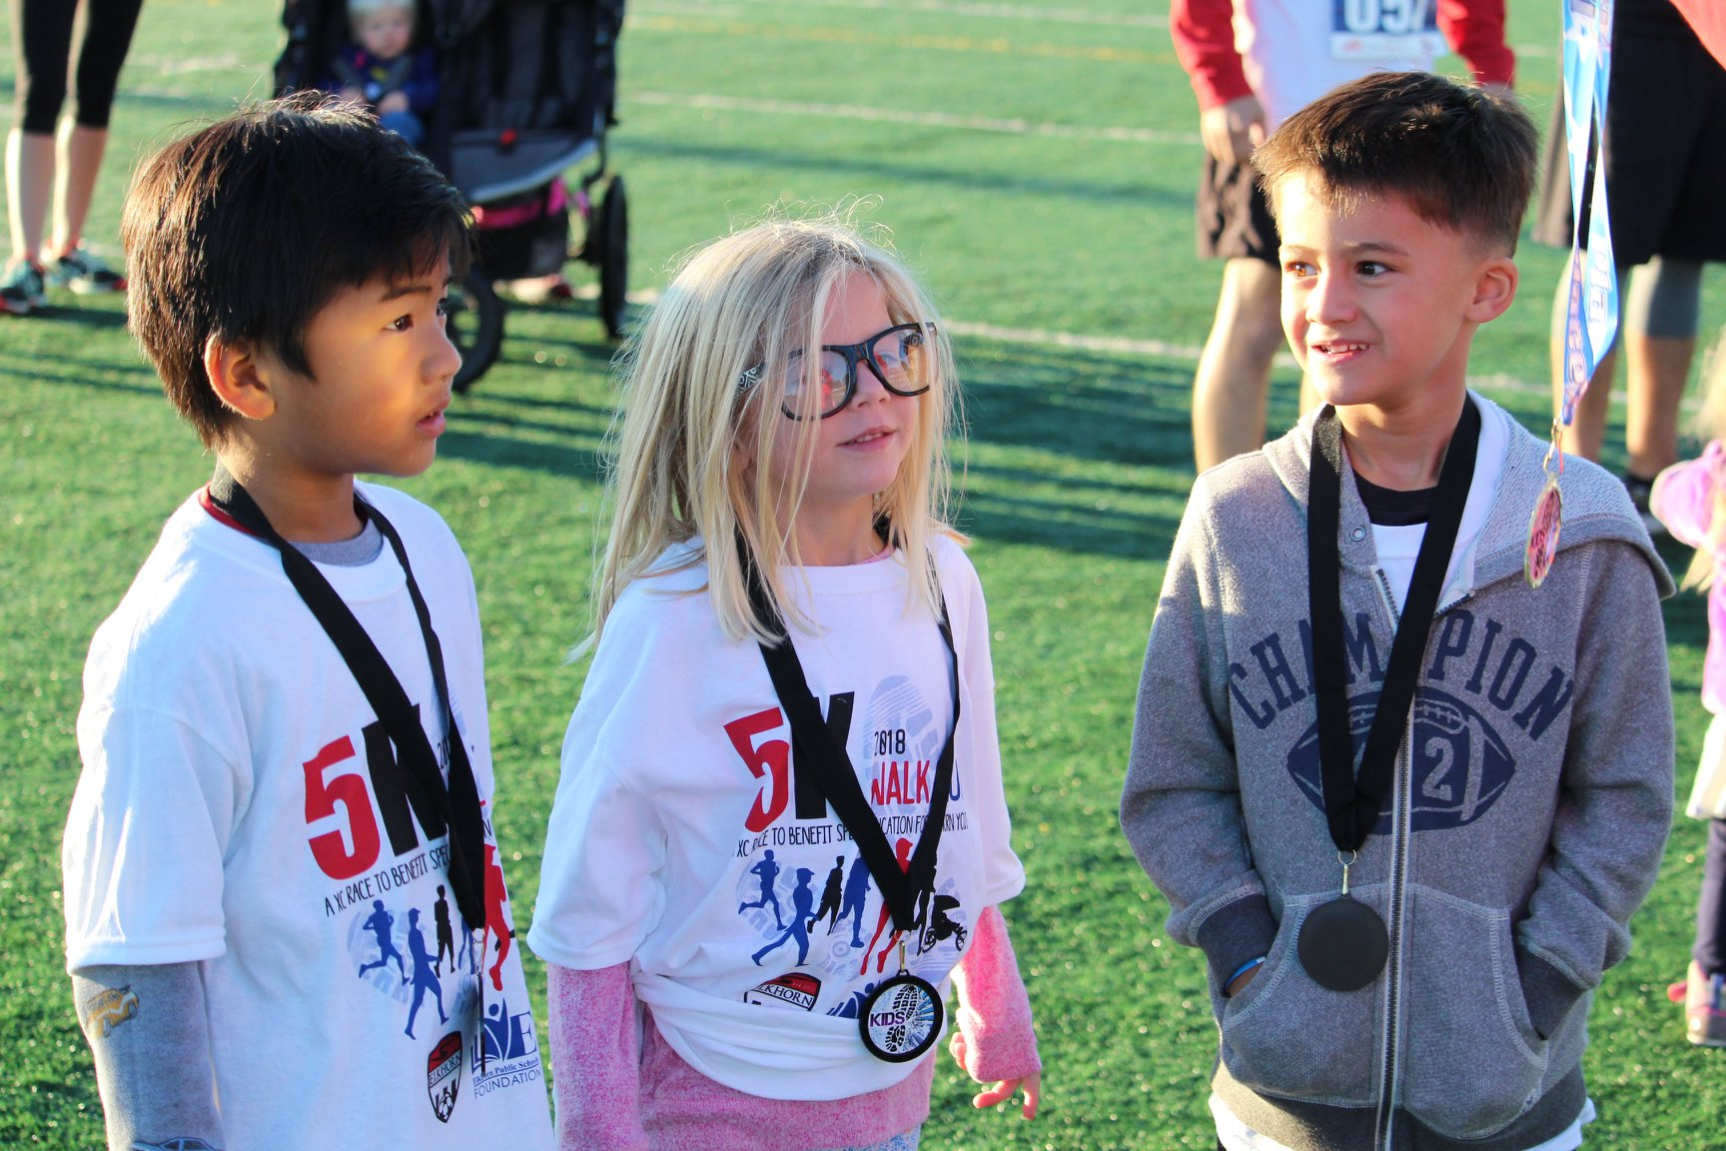

Photo #1 Caption: Participants in the Kids Dash pose for a picture after the race. A total of 30 kids participated in the 100 yard dash across Elkhorn football campus.

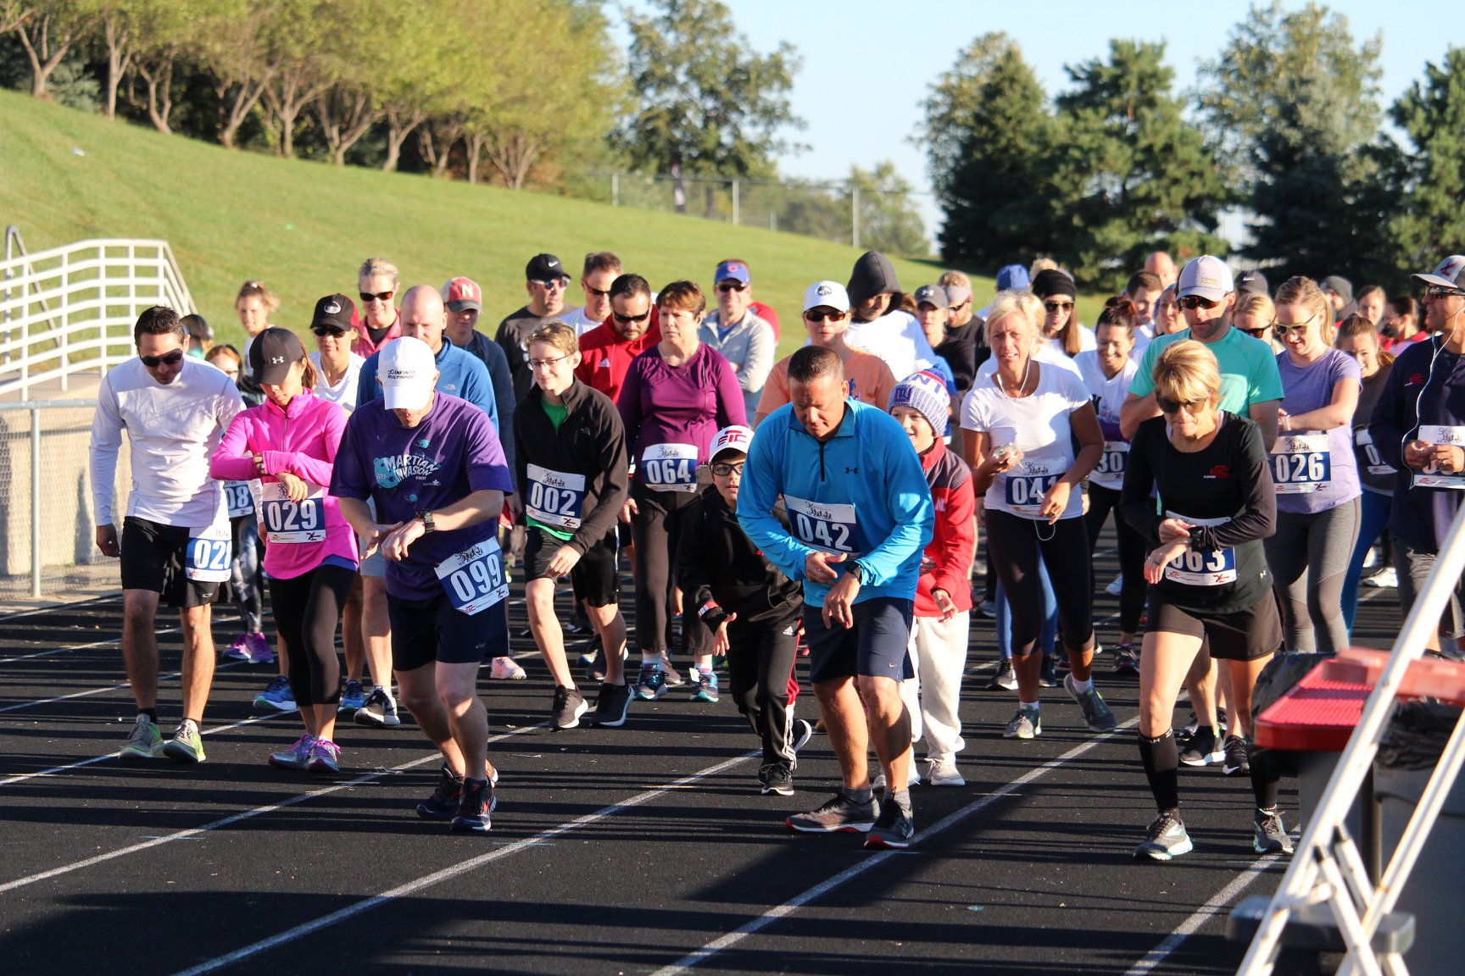
Photo #2 Caption: 5K runners lined up and ready for a great run! 95 runners signed up for the 2nd Annual 5k Race, benefitting special education programs for Elkhorn youth.

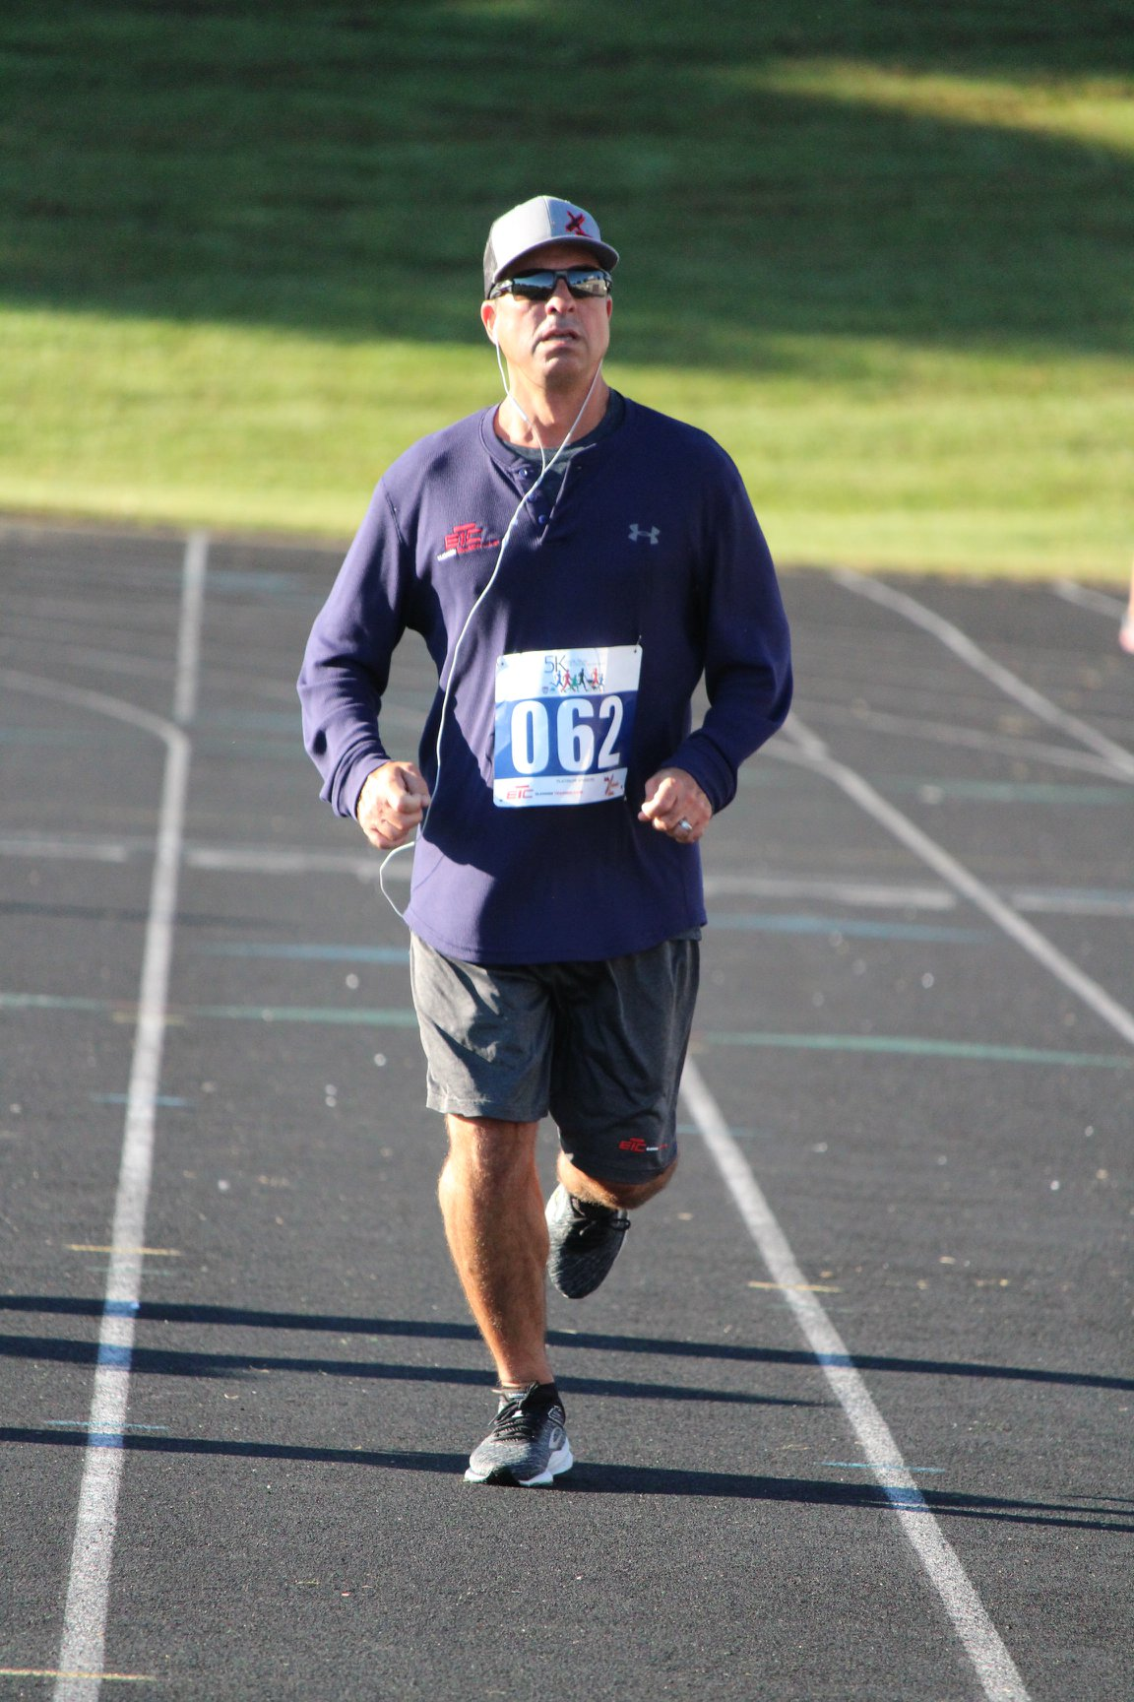

Photo #3 Caption: Mike Allesandro, Owner of Elkhorn Training Camp, finishes the last stretch of the 5K. Elkhorn Training Center was the Platinum Sponsor of this years event.

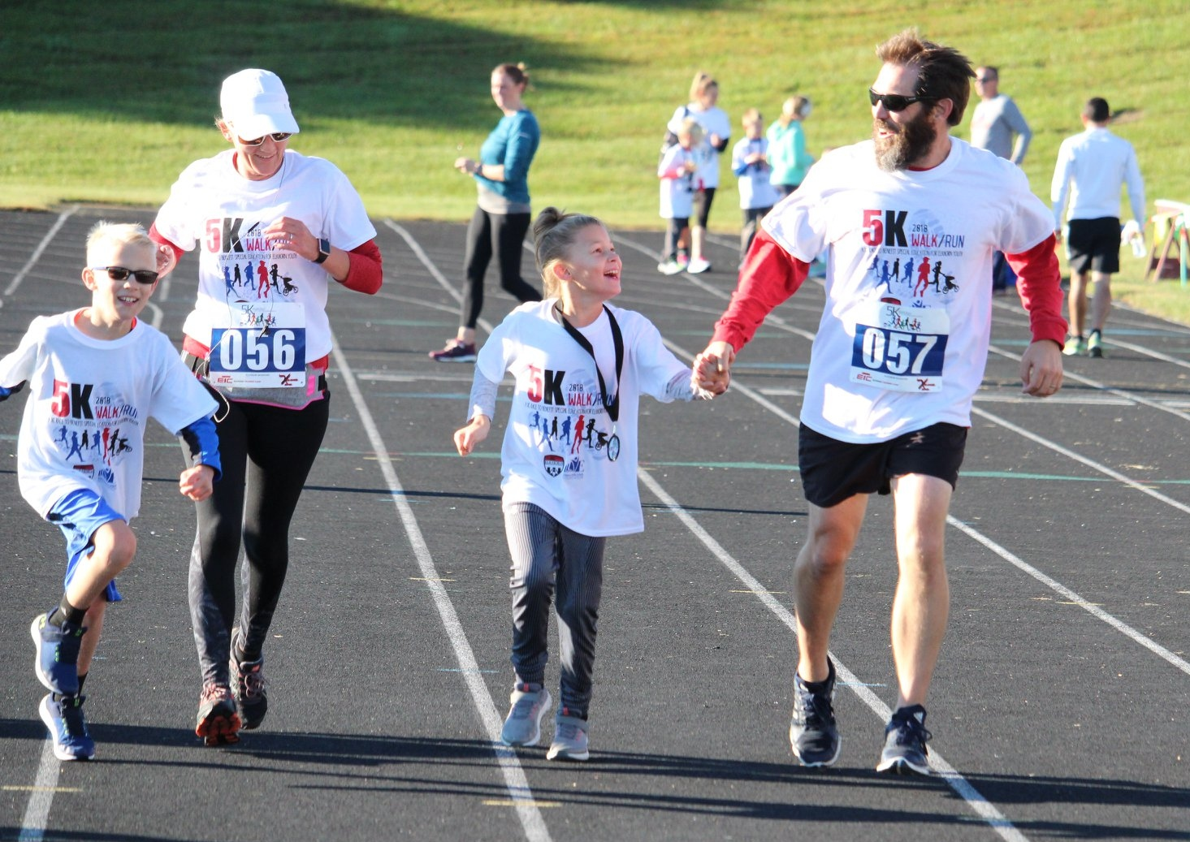
Photo #4 Caption: The Jeremy White family of Elkhorn crosses the finish line of the 5K race together.

-END-

