ELKHORN PUBLIC SCHOOLS FOUNDATION
HOSTS HALL OF FAME RECEPTION & AWARDS CEREMONY

Elkhorn NE: Thursday, October 30, 2014

Over 250 people attended the 20th Anniversary of the Elkhorn Public Schools Foundation Hall of Fame Celebration at Elkhorn South High School on October 26th. A total of 12 educators, support staff members, volunteers, alumni, and community boosters were inducted into the Hall of Fame, and past award winners and Foundation board members were recognized. The Foundation’s Classroom Grant program was also featured.

The Carl L. White Outstanding Educator of the Year award was presented to Christie Dean, Early Childhood Special Education Teacher at West Bay Early Education Preschool. Elizabeth Jones, EHS English Teacher, was honored as the Golden Apple Outstanding Educator. Jerry Frerichs was recognized as the Former Educator of the Year. Two Support Staff Members of the Year were honored: Wendy Henderson, Teacher Assistant at Manchester Elementary, and Scott Perrigo, Head Custodian at Elkhorn South High School.

Clarice Barnhill, Elkhorn High School Class of 1949, was recognized as Alumna of the Year for her service with the Western Douglas County Chamber of Commerce Food Basket Program and support of the Bethany Lutheran Church faith community. Calvin Bull, Elkhorn High School Class of 1975, was recognized as Alumnus of the Year for his dedication to the schools and community through his service and leadership on the Elkhorn Public Schools Board of Education. Jake and Spencer Long, both graduates from Elkhorn High School in 2009, were announced as Alumni Athletes of the Year and accepted their awards via video due to medical school and professional football conflicts.

Community Booster of the Year was awarded to Danny Szegda and the Omaha Trane Office. Michael Lynne, former educator and principal in New York, was honored as the Partners in Education Mentor of the Year. Tammy Knight was recognized as Volunteer of the Year for her dedication to the staff and students of Elkhorn Ridge Middle School.

“Since this year marked the 20th Anniversary of our Hall of Fame, we celebrated our very deserving 2014 award recipients, our past award winners, and our past and present Board of Directors,” said Stacey L. Falk, Executive Director of the Elkhorn Public Schools Foundation. “Their combined dedication, service, achievements and heart have helped create a culture of philanthropy and distinction here in Elkhorn.”

On behalf of the Foundation, Stacey Falk awarded a check to the Elkhorn Public Schools District for over $156,000 for classroom grants. Each school will receive a customized version of this check showing the amount awarded to that school and a listing of the businesses, families, and fundraisers that donated to the Grant A Wish campaign.

If you would like more information about the Elkhorn Public Schools Foundation, would like to nominate someone for an award, or find out how to contribute to the Foundation’s many programs, please contact Stacey Falk at 402.289.1727.

# # #

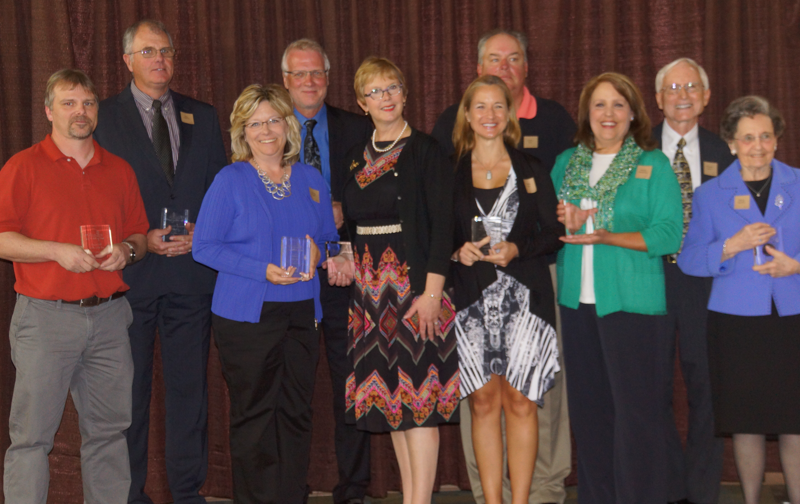

Photo #1 Caption (l-r): 2014 Hall of Fame Award Recipients: Scott Perrigo, Jerry Frerichs, Tammy Knight, Danny Szegda, Elizabeth Jones, Christie Dean, Calvin Bull, Wendy Henderson, Michael Lynne and Clarice Barnhill.

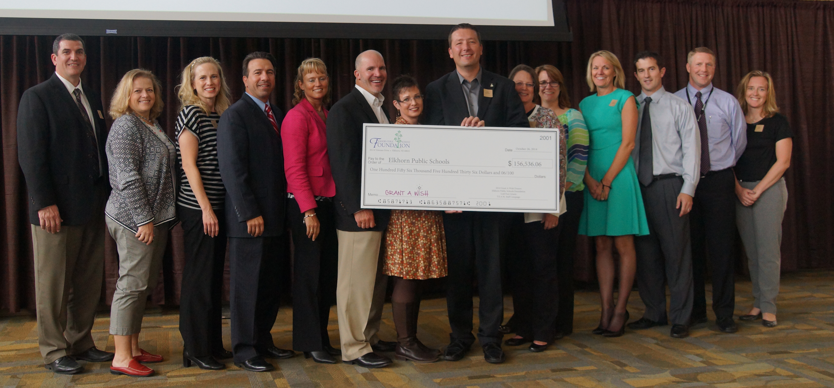

Photo #2 Caption: Elkhorn Public Schools representatives accepting the Classroom Grant Check at the Hall of Fame Celebration (l-r) Mike Tomjack (Elkhorn Grandview Middle School), Jean Herold (West Dodge Station Elementary School), Amy Christ (Manchester Elementary School), Dan Radicia (Elkhorn High School), Laurinda Petersen (Spring Ridge Elementary School), Chad Soupir (Elkhorn Valley View Middle School), Becky Vinchur (Elkhorn Ridge Middle School), Mark Kalvoda (Elkhorn South High School), Deb Garrison (Elkhorn Middle School), Anne Doerr (Fire Ridge Elementary School), Jan Peterson (Sagewood Elementary School), Troy Sidders (Westridge Elementary School), Andy Luebbe (Skyline Elementary School), and Jen Coltvet (West Bay Elementary School).

