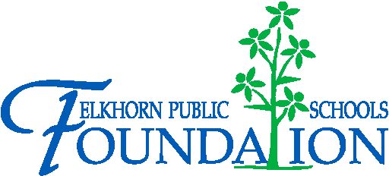

20214 VETERANS DRIVE, STE. 400 • ELKHORN, NE 68022
PRESS RELEASE
PRESS RELEASE
Contact: Stacey L. Falk, Executive Director FOR IMMEDIATE RELEASE
Elkhorn Public Schools Foundation November 09, 2015
402-289-1727 • sfalk@epsne.org
www.elkhornfoundation.org

ELKHORN PUBLIC SCHOOLS FOUNDATION HOSTS HALL OF FAME RECEPTION & AWARDS CEREMONY

Elkhorn, NE - Over 300 guests attended the 21st Annual Elkhorn Public Schools Foundation Hall of Fame Reception at Elkhorn South High School on October 25th. A total of 14 educators, support staff members, volunteers, alumni, and community boosters were inducted into the Hall of Fame. The event featured Elkhorn High School’s Jazz ensemble playing jazz tunes during the reception, and vocal students from West Dodge Station led the Pledge of Allegiance and sang for guests. The Elkhorn High School musical cast of TARZAN shared their talents and provided a sneak peek of their November production. An appetizer buffet and desserts were enjoyed by guests. The autumn harvest theme set the tone with large soft green pumpkins filled with an assortment of fall flowers adorning the tables, along with pictures of Elkhorn students enjoying many Classroom Grants in action! “It was a beautiful fall day as we celebrated with Elkhorn students and families of all ages, honoring so many deserving recipients. The many accomplishments shared about each recipient and the supportive guests in attendance was a testament to the amazing Elkhorn community we live in and the outstanding Elkhorn Public Schools family,” said Stacey Falk, Executive Director of the Elkhorn Public Schools Foundation.

During the Awards Ceremony, the Foundation inducted 14 members into its Hall of Fame. Stephanie (Kirby) Dowell, Elkhorn High School Class of 2000, was recognized as the Alumnus Athlete of the Year. Stephanie was an outstanding Elkhorn athlete who led the women’s UNO soccer team to a NCAA Division II Championship game in 2002 and National Semi-final appearance in 2003. Rex Barker, Elkhorn High School Class of 1977, was recognized as an Alumnus of the Year for his accomplishments as the Millard South High School band director for 27 years. Dr. Irmgard Kahl, a German foreign exchange student who graduated from Elkhorn High School in 1954, was also recognized as an Alumnus of the Year for her contribution as a judge. Former classmate, Sharron Gilson, accepted the award on behalf of Dr. Kahl.

The Carl L. White Outstanding Educator of the Year award was presented to Ron Phelps, science teacher at Elkhorn Ridge Middle School, for his 34 years of outstanding teaching for Millard and Elkhorn Public Schools districts. AXA Advisors was recognized as the Community Booster of the Year. AXA Advisors has been an annual sponsor of the Elkhorn Public Schools Foundation Golf Fore Grants fundraiser and has awarded over $25,000 in scholarships to Elkhorn students through the AXA Scholarship. Scott Newman and Mike Sufficool accepted the award on behalf of AXA Advisors. Former Educator of the Year was awarded to Dr. Roger Breed who was a well-respected Elkhorn Public Schools’ superintendent until 2009, when he was appointed to the position of Nebraska Commissioner of Education.

Molly Allen (Fire Ridge Elementary) and Kristen Schrock (Spring Ridge Elementary) were honored as the Golden Apple Outstanding Educators of the Year. This award is granted to an outstanding administrator or teacher who has been with the Elkhorn Public Schools District for five years or less. The Partners in Education Mentor of the Year award was presented to Judy DeSpain, former Millard teacher, for her dedication to mentoring students at Spring Ridge Elementary School. Jason Harris and Jeff Strickler were awarded Support Staff Members of the Year for their tireless efforts in the Information Technology department at Elkhorn Public Schools. Mitch Rohs and Ann Marie & Kurt Seevers were recognized as Volunteers of the Year. Mitch Rohs was recognized for his creative and constructive building abilities for Elkhorn Middle School, Elkhorn Grandview and Elkhorn High School drama programs. Kurt & Ann Marie Seevers have volunteered countless hours for the Elkhorn High School band program over the last eight years, as well as volunteering for PTO, booster clubs and many other community organizations.

On behalf of the Foundation, Stacey Falk awarded a check to the Elkhorn Public Schools District for over $126,000 for classroom grants. Each school will receive a customized version of this check showing the amount awarded to that school and a listing of the businesses, families, and fundraisers that donated to the Grant A Wish campaign.

If you would like more information about the Elkhorn Public Schools Foundation, would like to nominate someone for an award, or find out how to contribute to the Foundation’s many programs, please contact Stacey Falk at 402.289.1727.

# # #

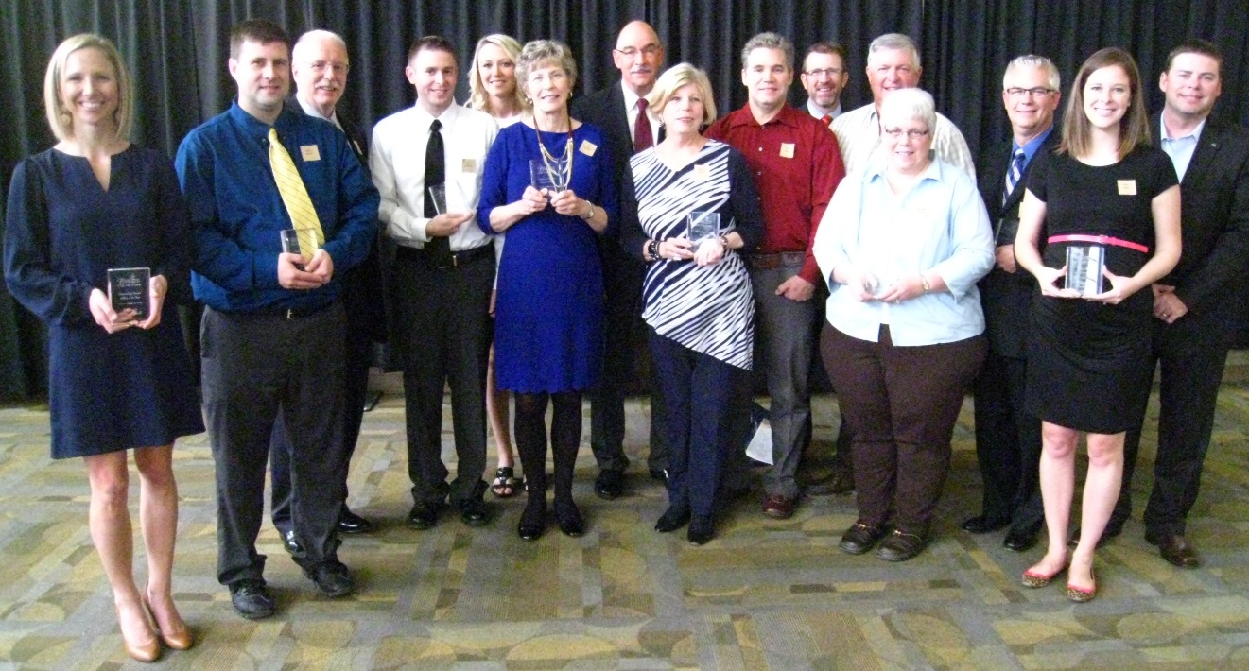

Photo #1 Caption: 2015 Hall of Fame Award Recipients (l-r): Stephanie Dowell, Jason Harris, Ron Phelps, Jeff Strickler, Kristen Schrock, Judy DeSpain, Dr. Roger Breed, Sharron Gilson (accepting on behalf of Dr. Irmgard Kahl, Mitch Rohs, Mike Sufficool, Kurt Seevers, Ann Marie Seevers, Rex Barker, Molly Allen and Scott Newman.

‘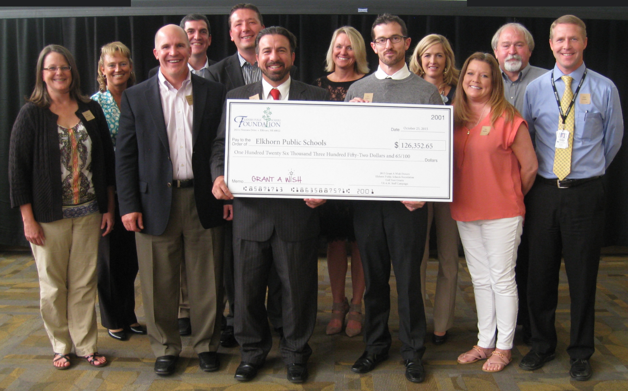

Photo #2 Caption: Elkhorn Public Schools representatives accepting the Classroom Grant Check at the Hall of Fame Celebration (l-r): Deb Garrison (Elkhorn Middle School), Laurinda Petersen (Spring Ridge Elementary School), Chad Soupir (Elkhorn Valley View Middle School), Mike Tomjack (Elkhorn Grandview Middle School), Mark Kalvoda (Elkhorn South High School), Dan Radicia (Elkhorn High School), Jan Peterson (Sagewood Elementary School), Troy Sidders (Westridge Elementary School), Deb Knutson (Fire Ridge Elementary School), Deb Madden (Hillrise Elementary School), Kevin Riggert (Elkhorn Ridge Middle School) and Andy Luebbe (Skyline Elementary School).

