20214 VETERANS DRIVE, STE. 400 • ELKHORN, NE 68022
PRESS RELEASE
PRESS RELEASE

Contact: Stacey L. Falk, Executive Director FOR IMMEDIATE RELEASE
Elkhorn Public Schools Foundation June 28, 2017
402-289-1727 • sfalk@epsne.org
www.elkhornfoundation.org

Elkhorn Public Schools Foundation raises over $34,000 for the Classroom Grant Program at its 18th Annual “Golf Fore Grants” Tournament

Elkhorn, NE - On Monday, June 12, 2017, over 155 golfers, volunteers & sponsors joined the fun at Shadow Ridge Country Club for Elkhorn Public Schools Foundation’s 18th annual Golf Fore Grants Tournament! This year the Golf Fore Grants event raised over $34,000 to benefit its Classroom Grants program. Over 150 wishes have been granted for the coming school year, including adapted archery equipment for students with disabilities, anti-bullying rallies, middle school play productions, smart projectors and more! The support from this tournament directly impacts more than 8,500 students in all of the 16 schools in the Elkhorn Public School District. “We are so thankful for our sponsors, golfers and volunteers!” stated Stacey L. Falk, Executive Director of the Elkhorn Public Schools Foundation. She continued, “The funds raised will help the Elkhorn Public Schools Foundation grant over 150 wishes for pre-school through High School classrooms! We are committed to our Elkhorn Public Schools’ students and teachers. We could not possibly grant these wishes without the involvement and generosity of all who joined us today, along with many other business sponsors and volunteers.”

The Foundation offered a morning 9-hole round which included a light breakfast and lunch. Unfortunately, weather limited the morning golfers to only get a few holes in. A four person 18-hole afternoon scramble began with lunch, followed by a noon shotgun start, and ended with a rib-eye dinner buffet. Chad Soupir, Elkhorn Valley View Middle School Principal, was a guest speaker who shared his school’s experience with the Foundation’s Classroom Grant Program and thanked the golf participants for their ongoing support of the Foundation. Elkhorn High School cheerleaders, Elkhorn Kids Campus employees, Foundation Board members, Christian Brothers Automotive, AXA Advisors, Woodhouse Auto Group, Sam & Louie’s Pizza and volunteers from Sodexo teamed up to help with games all along the course – including opportunities to win a new Alfa Romeo, free pizza for a year, putting green contest and much more.

The grand finale was the awards presentation announcing flag pin prizes consisting of Yeti 30 oz Rambler Mugs and Multi-function BBQ Tool Set, a poker contest, putting contest winners, raffle winner and afternoon tournament champions. Steve Baker, Dave Raymond, Josh Raymond and Tim Hughes were crowned “Golf Fore Grants” Tournament Champions.
The Foundation is seeking additional funding for the Classroom Grants program through its “Grant-A-Wish” campaign – enabling donors to help “grant” the Classroom Grant wishes of our teachers and school administrators. If you would like to support the Elkhorn Public Schools Foundation or find out more about classroom grants, contact Stacey L. Falk at (402) 289-1727 or visit www.elkhornfoundation.org.

# # #

20214 VETERANS DRIVE, STE. 400 • ELKHORN, NE 68022
PRESS RELEASE
PRESS RELEASE

Contact: Stacey L. Falk, Executive Director FOR IMMEDIATE RELEASE
Elkhorn Public Schools Foundation June 23, 2016
402-289-1727 • sfalk@epsne.org
www.elkhornfoundation.org

Photo caption 1:
Winners of the 18th Annual Elkhorn Public Schools Foundation's Golf Fore Grants Tournament were (l-r): Tim Hughes, Steve Baker, Dave Raymond and Josh Raymond.

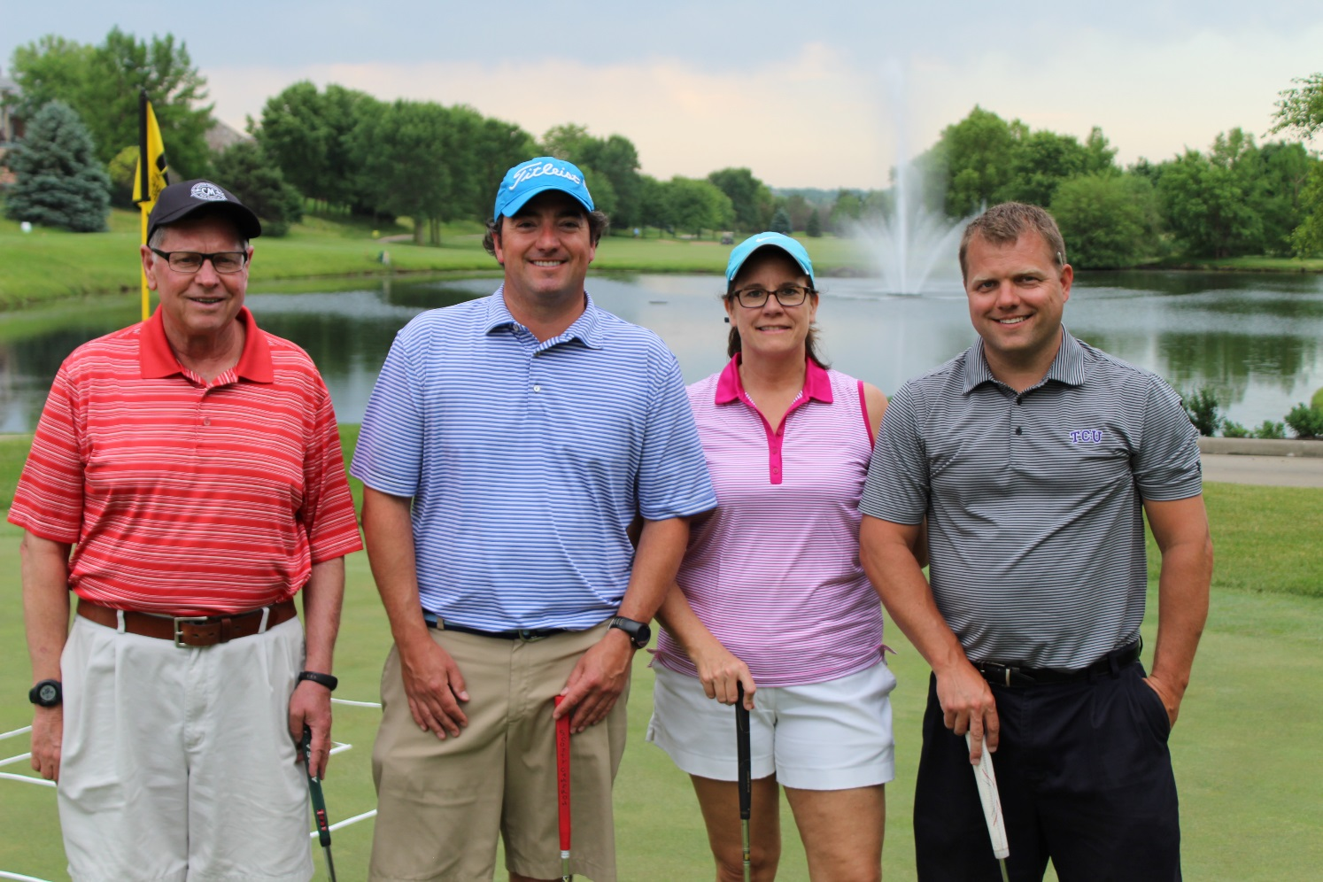

Photo caption 2:
The DA Davidson team consisted of (l-r) Al Herink, Paul Griger, Anne Doerr and Andy Forney. DA Davidson was one of two Dinner Benefactors for the Golf Fore Grants Tournament.

Photo caption 3:
The DLR Group consisted of Mike Tomjack, Curtis Johnson, Ryan Lindquist and Rick Dougherty. DLR Group was also a Dinner Benefactor at this year’s tournament.

-END-

