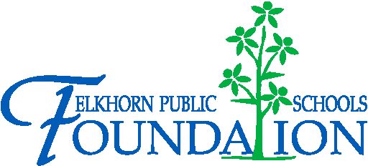

20214 VETERANS DRIVE, STE. 400 • ELKHORN, NE 68022
PRESS RELEASE
PRESS RELEASE

Contact: Stacey L. Falk, Executive Director FOR IMMEDIATE RELEASE
Elkhorn Public Schools Foundation June 30, 2016
402-289-1727 • sfalk@epsne.org
www.elkhornfoundation.org

Elkhorn Public Schools Foundation raises over $29,000 for the Classroom Grant Program at its 17th Annual “Golf Fore Grants” Tournament

Elkhorn, NE - On Monday, June 13, 2016, over 155 golfers, volunteers & sponsors joined the fun at Shadow Ridge Country Club for the 17th annual Golf Fore Grants Tournament! This year the Golf Fore Grants event raised over $29, 000 to benefit our Classroom Grants program, which funds grants in all 16 schools in the Elkhorn Public School district. Classroom “wishes” are requested for programs like robotics, science equipment, research tools, anti-bullying seminars, school plays, new technology and more by teachers and principals from each school every year. The support helps us grant these “wishes” to enhance education for more than 8,000 students! “At the Foundation, we believe in the potential of every student and are proud to be able to provide enrichment for our staff and students at all grade levels,” stated Stacey L. Falk, Executive Director of the Elkhorn Public Schools Foundation. She continued, “We are honored by the investment and generosity that our volunteers, sponsors and golfers shared with us today. It is a privilege for us to host this tournament as a demonstration to our commitment to the Elkhorn Public School System through the gift of education.
Thank you for helping us fulfill our mission of encouraging and supporting excellence in innovative education and school programs.”

The Foundation offered a morning 9-hole round which included a light breakfast, lunch and pin prizes. Greg Crawford, Joel Ringenberg, Chuck Woodside and Greg Twist were the morning pin prize winners. A four person 18-hole afternoon scramble began with lunch, was followed by a noon shotgun start, and ended with a rib-eye dinner buffet. ESHS cheerleaders, Elkhorn Kids Campus, Foundation Board members, GERST Painting, Woodhouse Auto Group, Sam & Louie’s Pizza and volunteers from AXA Advisors and Sodexo teamed up to help with games all along the course – including opportunities to win a new Lincoln MKZ, free pizza for a year, putting green contest and much more.

The grand finale was the awards presentation announcing flag pin prizes consisting of Yeti 30 oz Rambler Mugs and Jimmy John's certificate, a poker contest, putting contest winners, raffle winner and afternoon tournament champions. Bobby Deleidi, Jason Bartling, Andy Knutson and Erich Meyer were crowned “Golf Fore Grants” Tournament Champions.
The Foundation is seeking additional funding for the Classroom Grants program through the “Grant-A-Wish” campaign – enabling donors to help “grant” the Classroom Grant wishes of our teachers and school administrators. If you would like to support the Elkhorn Public Schools Foundation or find out more about classroom grants, contact Stacey L. Falk at (402) 289-1727 or visit www.elkhornfoundation.org.

# # #

20214 VETERANS DRIVE, STE. 400 • ELKHORN, NE 68022
PRESS RELEASE
PRESS RELEASE

Contact: Stacey L. Falk, Executive Director FOR IMMEDIATE RELEASE
Elkhorn Public Schools Foundation June 30, 2016
402-289-1727 • sfalk@epsne.org
www.elkhornfoundation.org
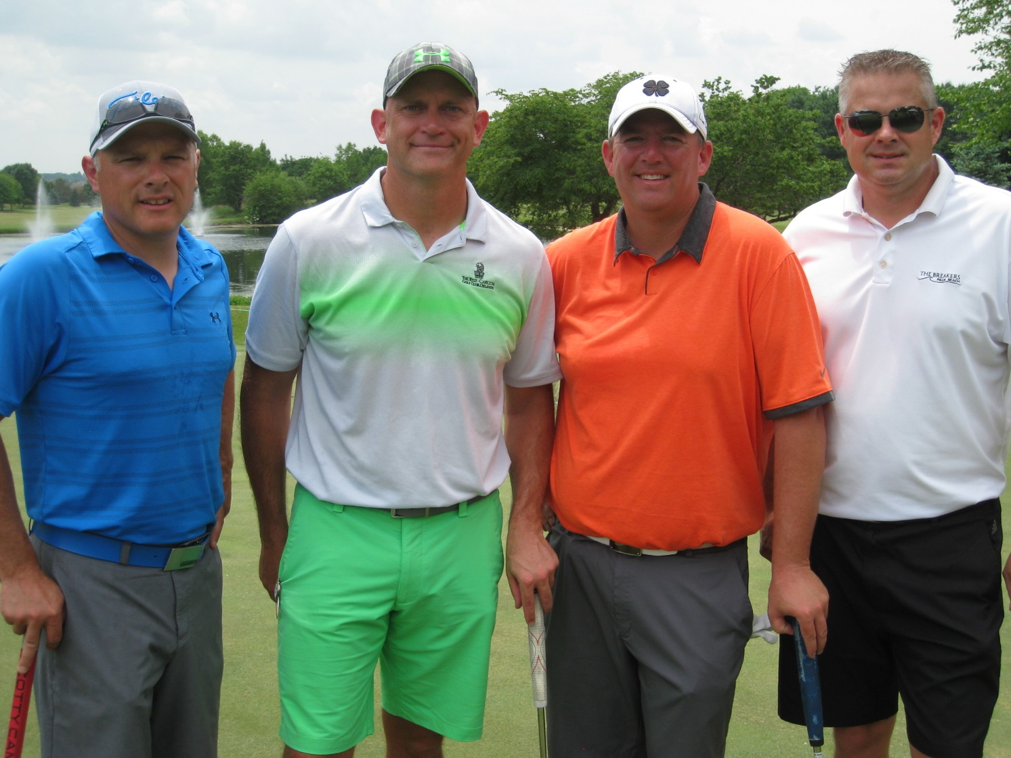

Photo caption:
Winners of the 17th Annual Elkhorn Public Schools Foundation's Golf Fore Grants Tournament were (l-r): Bobby Deleidi, Jason Bartling, Andy Knutson and Erich Meyer.

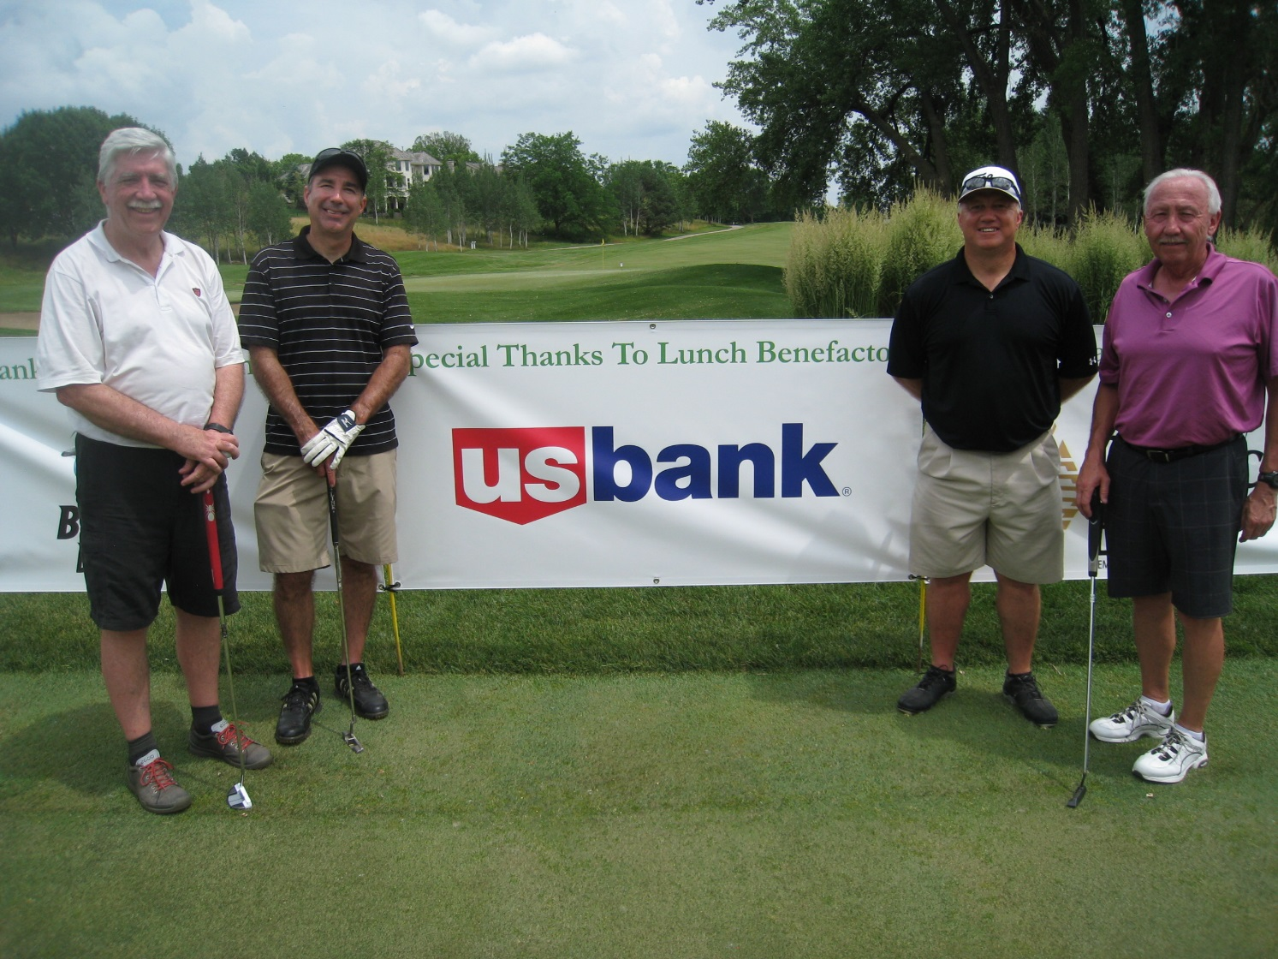

Photo caption:
The US Bank team of (l-r) Wood Hull, Mark Palmesano, Wayne Point and David Knutson won the putting green contest at the 17th Annual Elkhorn Public Schools Foundation's Golf Fore Grants Tournament.

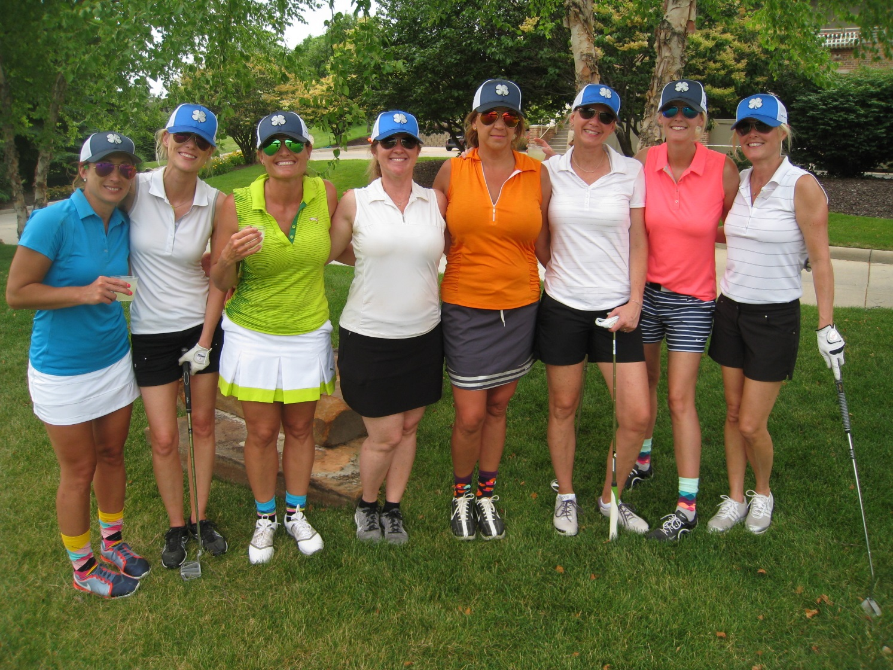

Photo caption:
Pictured are (l-r): Jamie Uphoff, Stephanie Deleidi, Jodi Bartling, Jody Tate, Rhonda Roy, Stacy Meyer, Angie Knutson and Gina Young enjoying their afternoon of golfing at the 17th Annual Elkhorn Public Schools Foundation's Golf Fore Grants Tournament.

-END-

