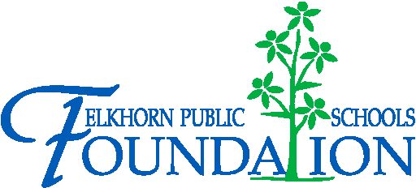

20214 VETERANS DRIVE, STE. 400 • ELKHORN, NE 68022
PRESS RELEASE
PRESS RELEASE
Contact: Stacey L. Falk, Executive Director FOR IMMEDIATE RELEASE
Elkhorn Public Schools Foundation April 20, 2016
402-289-1727 • sfalk@epsne.org
www.elkhornfoundation.org

Elkhorn Public Schools Foundation Raised $25,000+ at Bids 4 Kids Fundraiser

Elkhorn, NE - The Elkhorn Public Schools Foundation hosted the 4th Annual Bids 4 Kids Ladies Night Out on April 7, 2016, at The Ridge banquet facility in Elkhorn, NE. With over 200 guests in attendance, the community event raised more than $25,000 to help fund the Foundation’s Classroom Grants and Math and Reading Intervention programs at all 16 schools in the Elkhorn Public School District.

The event featured a silent auction, raffles, complimentary appetizers and desserts. To ensure that all patrons had the best silent auction experience at this year’s event, the Foundation utilized a mobile bidding platform through Qtego Auctions. This software allowed community members to bid on their favorite silent auction items through their mobile device, whether at the event or remotely. Over 150 local businesses and community partners donated auction items, food and raffle prizes. Each school in the district donated school experiences and sports camps for students and their families. The top raffle prize at this year’s event was a Hy-Vee Fill Your Cart shopping experience! This year’s winner will soon be experiencing 90 seconds of shopping at the local 156th & Maple Hy-Vee location.

“We are ecstatic at the success of this year’s Bids 4 Kids event!” said Executive Director Stacey Falk. “This year’s event was our most profitable and it can all be attributed back to the generosity of our donors, volunteer support, attendees and auction participants. Through the funds raised, we will be able to help students at every grade level. It is truly amazing to see the outpouring of support we have for our area students and educational programs. Thank you to everyone who was a part of this great event!”

To view photos from the 2016 Bids 4 Kids event, or to learn more about upcoming Foundation events, please visit www.elkhornfoundation.org.

Victory

-END-

