ELKHORN PUBLIC SCHOOLS FOUNDATION
HOSTS HALL OF FAME BANQUET

Elkhorn NE: Thursday, October 25, 2012

Over 250 people attended the Elkhorn Public Schools Foundation’s 18th Annual Hall of Fame Banquet, held at Elkhorn South High School on October 21st. A total of eleven educators, alumni, volunteers and community boosters were inducted into the Hall of Fame during the event. Additionally, a silent auction of selected student artwork raised more than $1,300 in support of the Elkhorn Public Schools Foundation’s Arts scholarship.

Four educators were recognized during the evening. The Carl L. White Educator of the Year was awarded to Suzy Richardson, a kindergarten teacher at Westridge Elementary. Mrs. Richardson is applauded as “an amazing teacher with determination and a compassionate heart – a truly winning combination.” Kiley Bassett, math and science teacher at Elkhorn Middle School, received the Golden Apple Educator of the Year for her innovative teaching techniques and always pushing her students to do their best. Elkhorn Valley View’s accompanist, Aylssa Boche, was the recipient of the Support Staff Person of the Year for going above and beyond - writing and rearranging music on the spot for the ever changing voices of middle school students. And, Former Educator of the Year was awarded to Judy Breed for 24 years of dedication to teaching and coaching Elkhorn students.

Three outstanding alumni were inducted into the Hall of Fame. Elkhorn Outstanding Alumnus, Gene Denker, was honored for his significant contribution of time, effort and support for countless Elkhorn students in activities and competitions at all grade levels. Patrick Gottsch, Founder and President of RFD-TV and RURAL-TV, was also honored as Elkhorn Outstanding Alumnus for serving rural America with TV networks that reflect the small-town, family-oriented values learned growing up in Elkhorn. Jill Dau Richmond, Elkhorn High School athlete who lettered in three sports each year of high school and was a member of the only Girls State Basketball Championship team thus far, was recognized as the Outstanding Alumnus Athlete of the Year.

The Elkhorn Public Schools Foundation also honored several people who support the district and Foundation. Dan Smith and D.A. Davidson were recognized as Community Booster of the Year for generously contributing in support of Classroom Grants, Golf Fore Grants, and the Hall of Fame Banquet. Steve and Toni Nichols were named the Volunteers of the Year for their work throughout the district and community. Toni has served as PTO President, Celebration of Giving Coordinator, Girls on the Run coach, read in character at the Bess Johnson Library, and volunteered for St. Patrick’s Church. Steve has served as Treasurer for the most recent Elkhorn Public Schools bond issue, Treasurer for the Rotary Club of Western Douglas County and the Waterloo Masonic Lodge, and YMCA coach. Jerry Rainey was honored as the Partners in Education Mentor of the Year for being an advocate for the program. With Jerry’s help in recruiting, Partners in Education paired 50 new mentors with students throughout the Elkhorn Public Schools District last year.

“The dedication, generosity and enthusiasm of our honorees are cause for celebration tonight,” said Stacey L. Falk, Executive Director of the Elkhorn Public Schools Foundation. “The Foundation is proud to honor these outstanding educators, alumni, volunteers and community partners for fostering excellence in education , providing greater opportunities for the students in the Elkhorn Public Schools, and truly making a difference in our community.”

The Hall of Fame banquet received support from numerous community members, businesses, and parent-teacher organizations. Trane and DLR were banquet benefactors; Sid and Dawn Dinsdale, Larry and Kathleen Peterson, and Vetter Health Services were dinner patrons; Jim and Sonia Church, Wood and Susan Hull, Ed and Julie Pullen of CCS Presentation Systems, Brian and Becky Vinchur, and Fred Witecy of No Frills Supermarkets were table sponsors; and Publication Printing provided the banquet programs. Several Hall of Fame and Foundation Friends also supported the event, including American Interstate Bank, Barney and Clarice Barnhill, Paul and Shelly Baumert, Larry and Maureen Bock, Harlan and Nancy Custard, William and Sharon Daily, Robert and Diana Foster, John and Carmen Housley, Mary Belle Pfeil, Dian Warren, Elkhorn Middle School Booster Club, and the parent-teacher organizations of Fire Ridge, Hillrise, Manchester, Skyline, Spring Ridge, West Dodge Station, and Westridge elementary schools.

If you would like more information about the Elkhorn Public Schools Foundation or how to contribute to its many programs, please contact Stacey Falk at 402-289-1727.
# # #
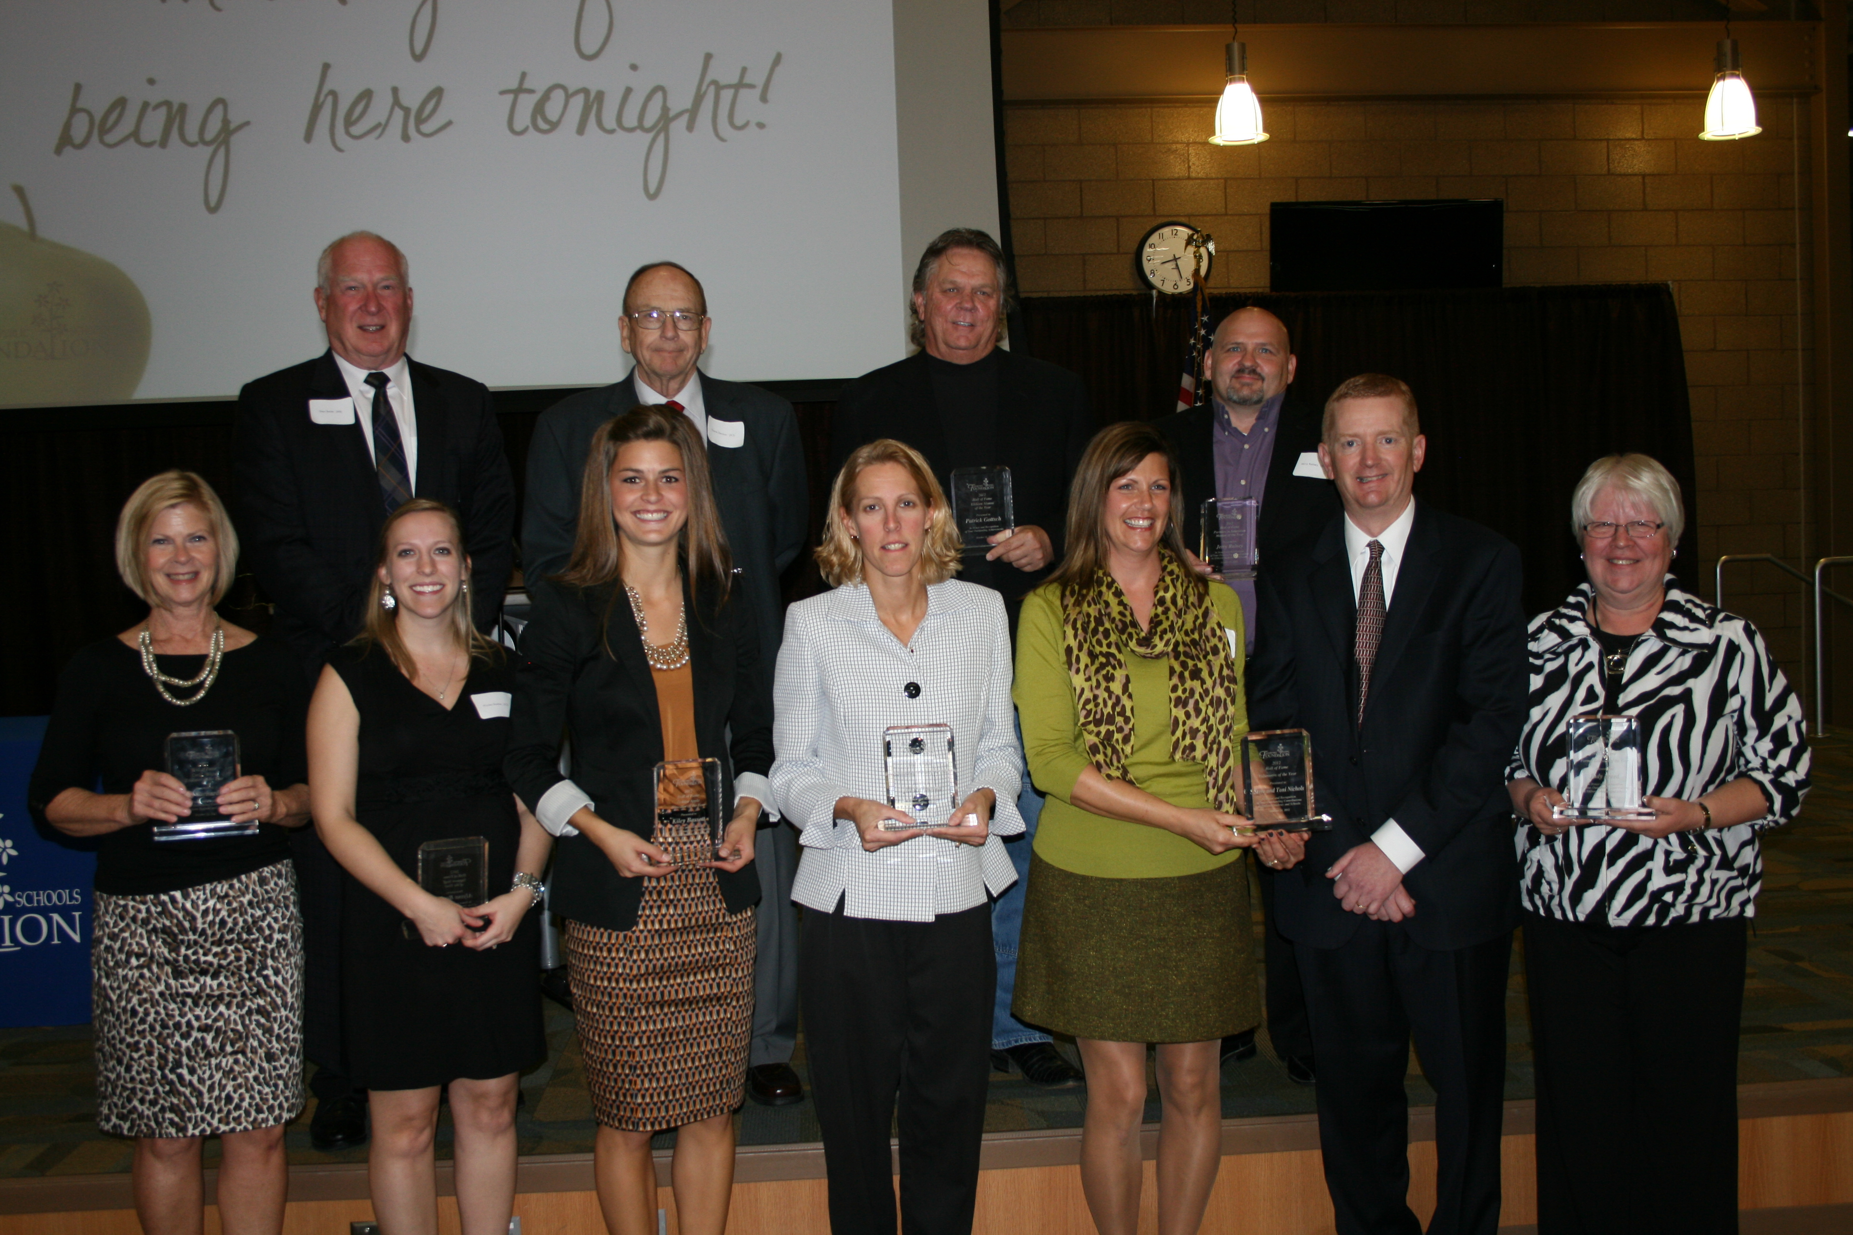
Photo Caption:
Front Row (l-r): Suzy Richardson, Alyssa Boche, Kiley Bassett, Jill Dau Richmond, Toni and Steve Nichols, Judy Breed
Back Row (l-r): Dan Smith, Gene Denker, Patrick Gottsch, Jerry Rainey

