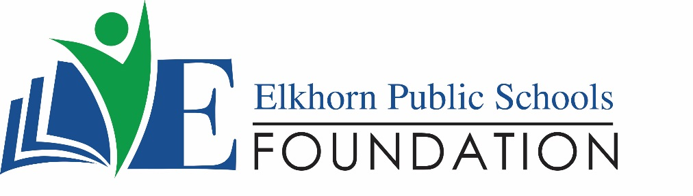

20272 VETERANS DRIVE • ELKHORN, NE 68022
PRESS RELEASE
PRESS RELEASE
Contact: Stacey L. Falk, Executive Director FOR IMMEDIATE RELEASE
Elkhorn Public Schools Foundation May 17, 2019
402-289-1727 • sfalk@elkhornfoundation.org
www.elkhornfoundation.org

Elkhorn Public Schools Foundation RaiseS $47,000 at Bids 4 Kids Fundraiser

Elkhorn, NE - The Elkhorn Public Schools Foundation hosted its 7th Annual Bids 4 Kids Ladies Night Out on April 4th at The Elkhorn Alumni Center. With over 200 guests in attendance, the community event raised $47,000 to help fund the Foundation’s Math & Reading Intervention programs. This school year, over 500 students participated in the program, with teachers spending an additional 3,000 instructional hours outside of the normal school day to help increase students test scores, boost students confidence and improve overall reading and math comprehension. The growing need of this tutoring program truly speaks to the importance of the Annual Bids 4 Kids event!
Over 200 local businesses and community partners donated auction items and raffle prizes for Bids 4 Kids! Almost all elementary school PTOs donated a basket for the auction, and each school in the district donated either school experiences or sports camps. Raffle prizes included decorative door hangers, 18” Nothing Bundt Cakes, and a chance to win a Hy-Vee 90 second Fill Your Cart shopping experience at the local 156th & Maple Hy-Vee location. Guests could purchase a bottle of wine from the wine pull or pick a gift card from the gift card tree.
Popperista Gourmet Popcorn provided popcorn for guests to munch on while perusing the silent auction items. Guests socialized on both levels of the Foundation office building and were treated to an amazing assortment of heavy appetizers and desserts compliments of Sam & Louie’s Catering of Elkhorn, Sodexo, Hy-Vee and Family Fare. This year’s Platinum Sponsor was Montessori Educational Centers of Omaha who generously donated $1,250 towards the event and mission of The Foundation. The Gold Sponsor was Milford Real Estate Group, and there were 11 other local businesses at the Silver & Bronze level sponsorships.
The Foundation utilized a mobile bidding platform by Qtego Auctions to ensure that all patrons had the best silent auction experience. Qtego’s software allowed community members to bid from their mobile device both at the event and remotely! Over 420 participants registered their phones enabling them to bid from the comforts of their couch or between baseball innings from the bleachers.
Within a 15 minute time period at the end of the event, patrons raised $1,900 during the “Fill the Heart” campaign! “There is one reason the Elkhorn Public Schools keeps growing by leaps and bounds every year – people are attracted to this community, and we feel very fortunate to be part of it!” said Executive Director, Stacey L. Falk. “As our district grows, so do its needs. Fundraisers like our Bids 4 Kids event help us continue to fund programs that enrich education and expand opportunities for Elkhorn students. Due to the outpouring of support from our donors, volunteers, attendees, and auction participants, this year we exceeded our fundraising goal! Thank you to everyone who was a part of our annual ladies event! Your dedication to the students and schools in Elkhorn is outstanding and exemplifies the generous spirit of our community as a whole”
###

The Elkhorn Public Schools Foundation is a non-profit organization dedicated to funding educational opportunities for students in the Elkhorn Public Schools District. Founded in 1983, the Foundation promotes student achievement and the unity of our community and its public schools by encouraging, supporting and recognizing excellence in innovative education, quality school programs and civic involvement. For more information about the Elkhorn Public Schools Foundation, visit www.elkhornfoundation.org.

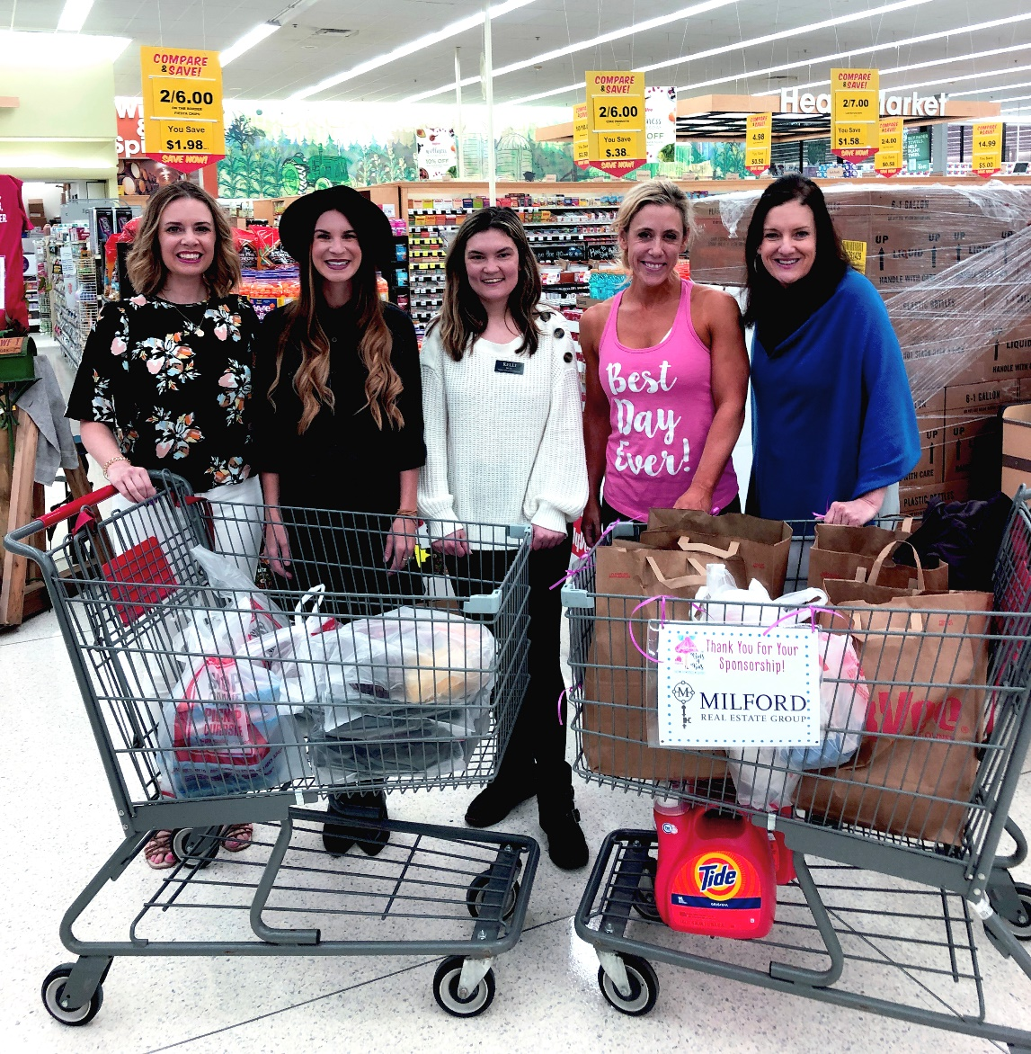

Photo #1 Caption: Kendra Ringenberg, winner of the Elkhorn Public School Foundation’s top raffle prize at the 2019 Bids 4 Kids event, claimed her 90 Second Hy-Vee Shopping Experience on May 7th. The Foundation partnered with Hy-Vee on 156th & West Maple Road, and Milford Real Estate Group sponsored this prize. Kendra had 90 seconds to fill her cart and was able to snag up $574 in groceries. Featured are (l-r): Stacey Selk (Marketing & Events Manager EPSF), Rachel Joy (Milford Real Estate Group Creative Director), Kelli Mull (Hy-Vee Marketing Manager), Kendra Ringenberg and Stacey L. Falk (Executive Director EPSF).

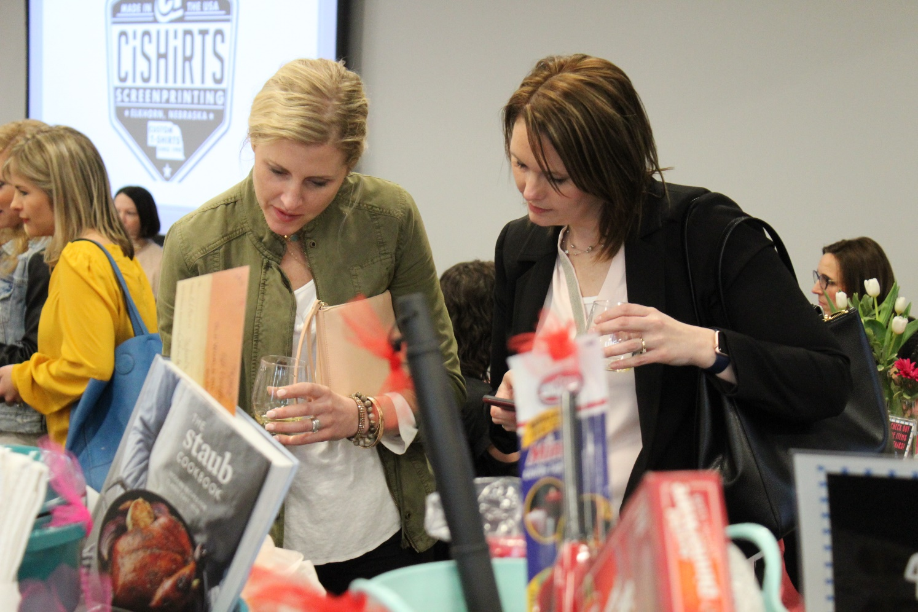

Photo #2 Caption: Event attendees browse auction item selections and decide if they will make a bid. The Foundation utilized a mobile bidding platform, allowing over 420 community members to bid on silent auction packages at the event or remotely.

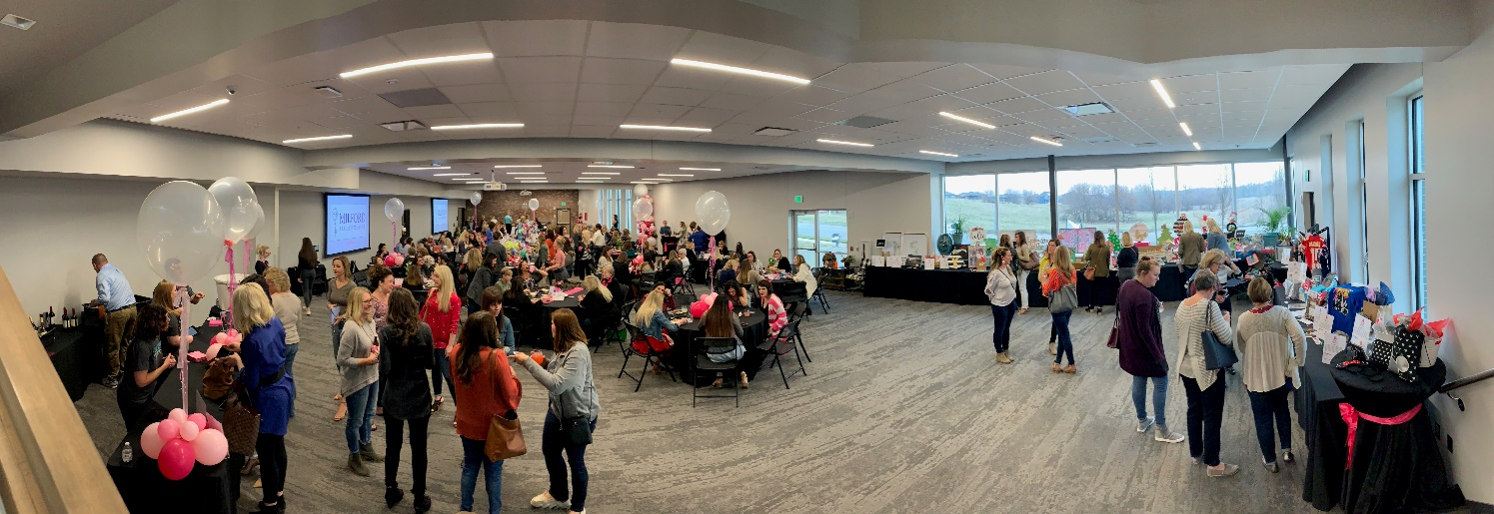
Photo #3 Caption: Over 200 guests attended the 7th Annual Bids 4 Kids event on April 4th at The Elkhorn Alumni Center. Proceeds from the event benefit the Elkhorn Public School Foundation’s Math & Reading Intervention Programs held at all 11 elementary schools in the Elkhorn Public School District.

-END-

