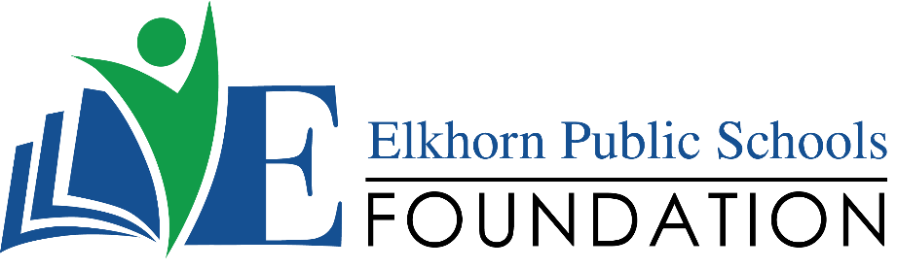

20214 VETERANS DRIVE, STE. 400 • ELKHORN, NE 68022
PRESS RELEASE
PRESS RELEASE

Contact: Stacey L. Falk, Executive Director FOR IMMEDIATE RELEASE
Elkhorn Public Schools Foundation June 25, 2018
402-289-1727 • sfalk@epsne.org
www.elkhornfoundation.org

Elkhorn Public Schools Foundation raises over $44,000 for the Classroom Grant Program at its 19th Annual “Golf Fore Grants” Tournament

Elkhorn, NE - On Monday, June 4, 2018, over 170 golfers, volunteers & sponsors joined the fun at new venue Champions Run Golf Course for Elkhorn Public Schools Foundation’s 19th annual Golf Fore Grants Tournament. The weather was perfect - truly a top 10 day - for the sold out tournament. This year the Golf Fore Grants event raised over $44,000 to benefit the Foundation’s Classroom Grants program, helping fund 96 wishes totaling $111,000. A few of the grants approved include anti-bullying programs, Lego robotics equipment, SMART projectors, and interactive books. The Foundation’s Classroom Grants Program directly impacts more than 9,000 students in all of the 17 schools in the Elkhorn Public School District. “On behalf of the Elkhorn Public Schools Foundation, we would like to thank every participant, sponsor and volunteer. A considerable portion of our success is due to the commitment made by you and your support of the Foundation’s Classroom Grant Program.” stated Stacey L. Falk, Executive Director of the Elkhorn Public Schools Foundation. She continued, “We are thrilled to share that this year’s event is our most successful golf tournament to date. With your donation, you are providing educational enhancements for the students of Elkhorn Public Schools.”

The Foundation offered a four person 18-hole afternoon scramble which began with lunch, followed by a noon shotgun start, and ended with a rib-eye dinner buffet. Elkhorn South High School cheerleaders, Elkhorn Kids Campus employees, Foundation Board members, AXA Advisors, Woodhouse Auto Group, Foundation Friends and volunteers from Sodexo teamed up to help with games all along the course – including opportunities to win a new Alfa Romeo, PITCH Pizzeria Wine Basket, putting green contest and much more.

The grand finale was the awards presentation announcing flag pin prizes consisting of golf shoe bags, bbq tool set and Scooters Gift Cards – donated by Scooters of Elkhorn. Winners were also announced for the poker contest, putting contest, raffle prizes and afternoon tournament champions. The tournament team champions were Jim Church, Bill Yates, Jon Peterson, and Gary Major.
The Foundation is seeking additional funding for its Classroom Grants program through its “Grant-A-Wish” campaign – enabling donors to help “grant” the Classroom Grant wishes of our teachers and school administrators. If you would like to support the Elkhorn Public Schools Foundation or find out more about classroom grants, contact Stacey L. Falk at (402) 289-1727 or visit www.elkhornfoundation.org.

# # #

20214 VETERANS DRIVE, STE. 400 • ELKHORN, NE 68022
PRESS RELEASE
PRESS RELEASE

Contact: Stacey L. Falk, Executive Director FOR IMMEDIATE RELEASE
Elkhorn Public Schools Foundation June 23, 2016
402-289-1727 • sfalk@epsne.org
www.elkhornfoundation.org
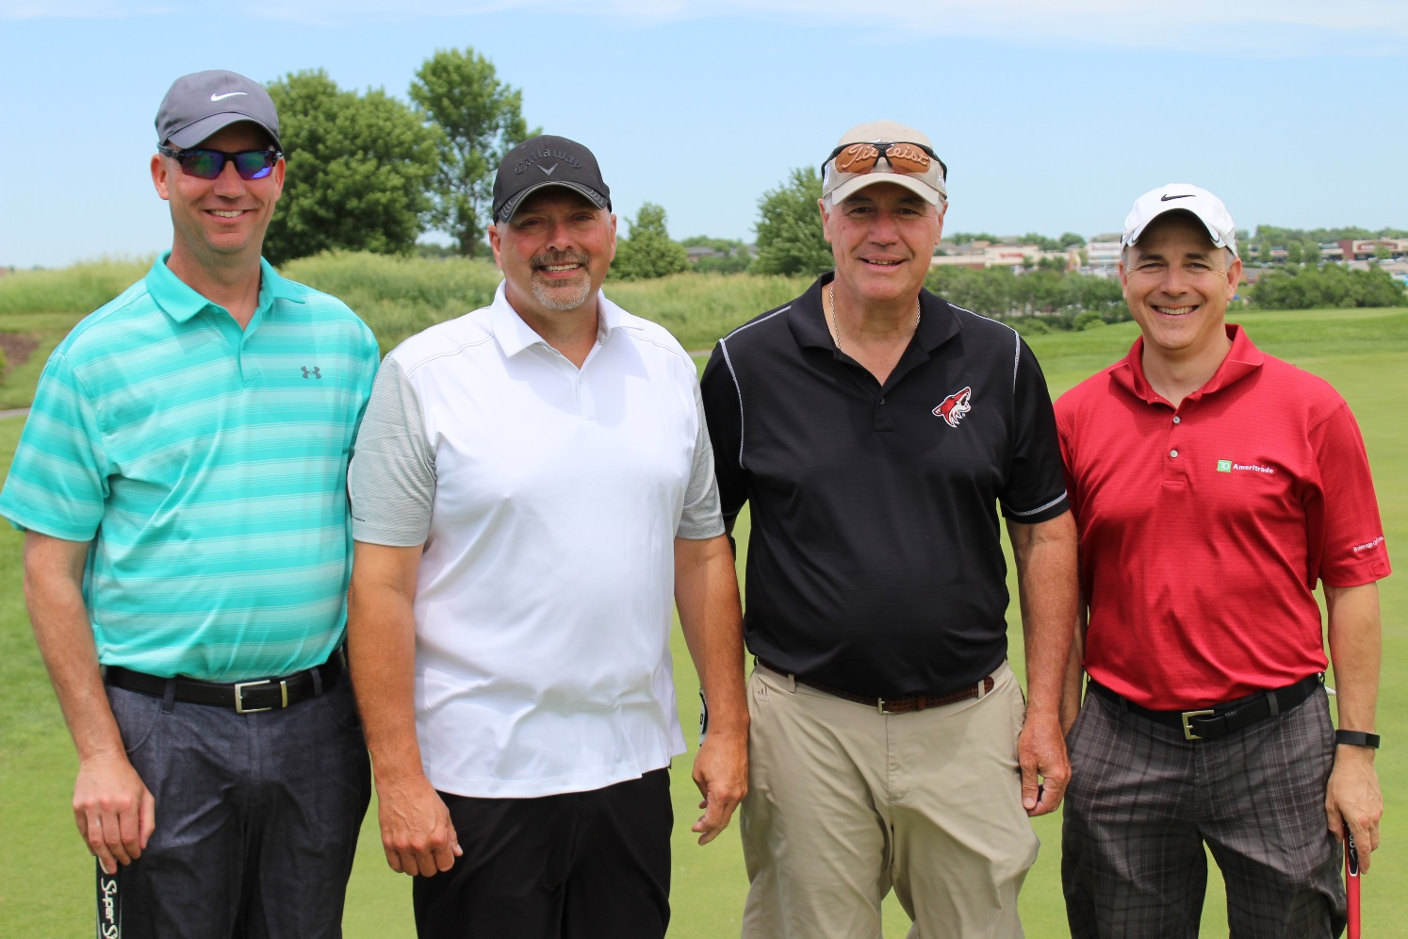

Photo caption 1:
Winners of the 19th Annual Elkhorn Public Schools Foundation's Golf Fore Grants Tournament were (l-r): Jon Peterson, Jim Church, Gary Major and Bill Yates.

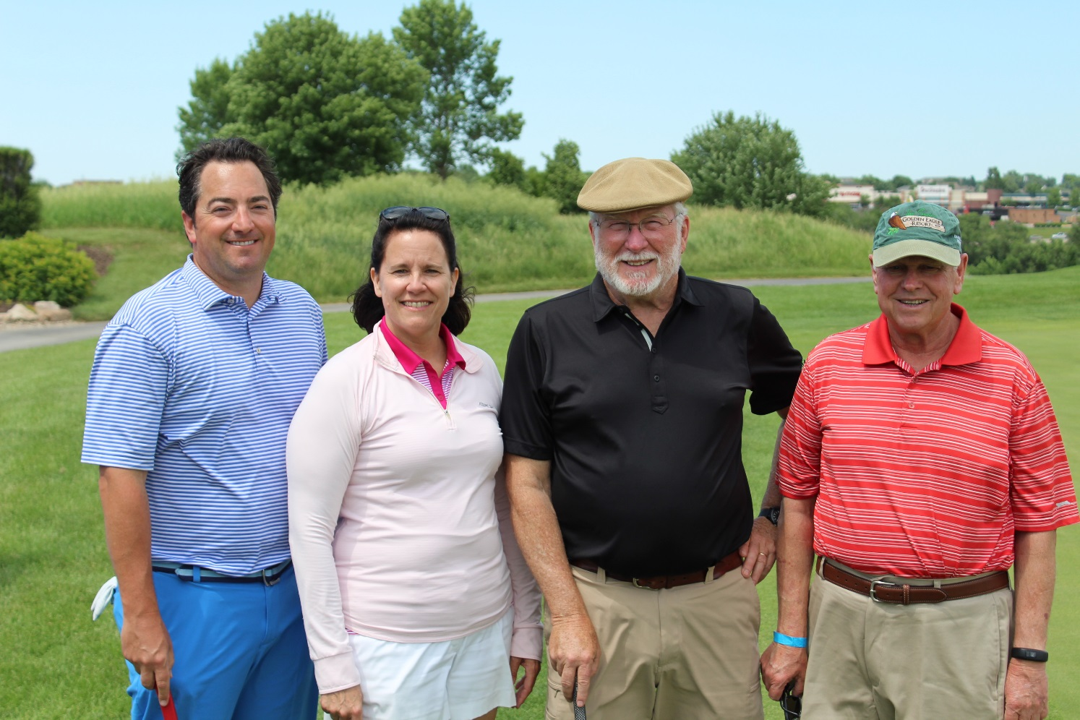

Photo caption 2:
The DA Davidson team consisted of (l-r) Paul Griger, Anne Doerr, Dan Smith and Al Herink,. DA Davidson was one of three Dinner Benefactors for the Golf Fore Grants Tournament.

-END-

