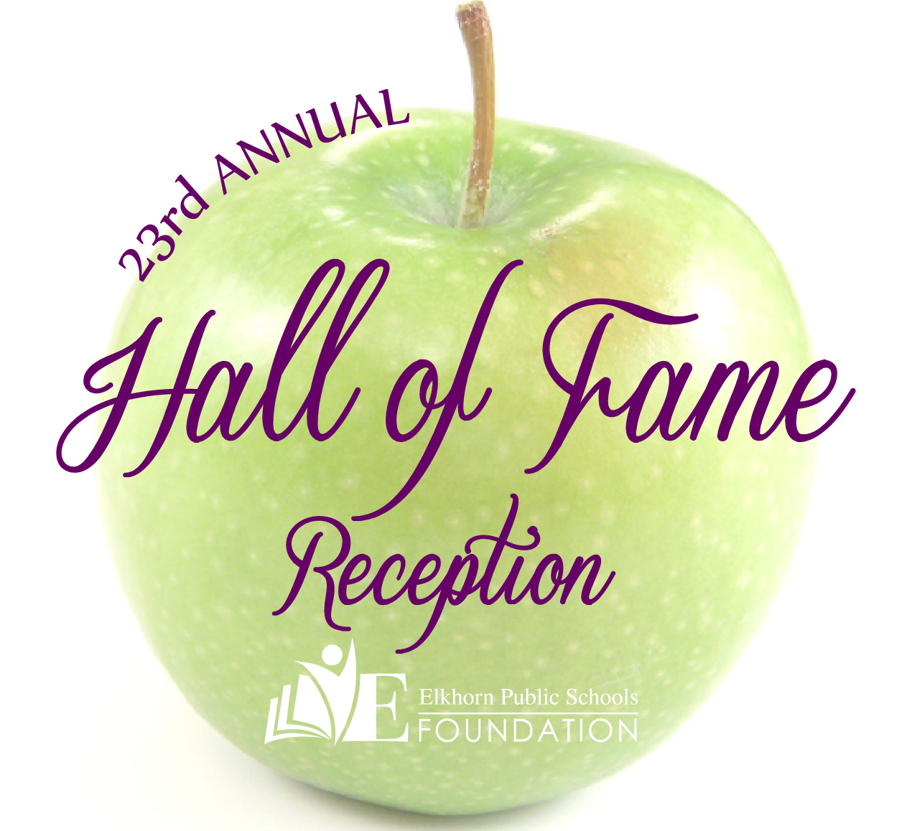


2017 Hall of Fame Awards Nomination
Please join the Elkhorn Public Schools Foundation in honoring community members, groups and/or businesses that have made significant and positive contributions to Elkhorn students, schools or the Elkhorn community at our Hall of Fame Awards Ceremony and Reception to be held at Elkhorn South High School during the end of October 2017.

Your Name: ______________________________________ Phone: _______________________
Email: _________________________________________________________________________

- Carl L. White Educator of the Year - Administrator or teacher who has been with the Elkhorn Schools District for 5 years or more and has positively affected the educational experience of Elkhorn students.
Nominee Name:

- Golden Apple Educator of the Year - Present administrator or teacher who has been with the Elkhorn Schools District for 5 years or less and has positively affected the educational experience of Elkhorn students.
Nominee Name:

- Former Educator of the Year - Past administrator or teacher who made a significant and memorable contribution to Elkhorn students’ education and has been retired for at least five years.
Nominee Name:
- Support Staff Member of the Year - Current Elkhorn Public Schools support staff member who makes a substantial difference with Elkhorn students and schools.
Nominee Name:
- Alumnus of the Year (This can include Athletes) – Elkhorn Public Schools graduate who has made an outstanding contribution to his/her community and/or profession.
Nominee Name: Class Year:
- Partners in Education Mentor of the Year - Partners in Education adult mentor who has made a notable difference in the education and life experiences of an Elkhorn student.
Nominee Name:
- Community Booster of the Year - Community individual, group and/or business that has supported Elkhorn students, Elkhorn Public Schools, and/or the Elkhorn community in positive and noteworthy ways.
Nominee Name:
- Volunteer of the Year - Community individual who has made significant and positive contributions to Elkhorn students.
Nominee Name:
Please describe why the individual(s) you are nominating should be selected for these honors and include any additional pages or information if desired.

Please return this completed form by May 31, 2017 to:
20214 Veterans Drive, Suite 400, Elkhorn NE 68022 or email to cmonnier@epsne.org. Thank you!
Hall of Fame Honorees

Carl L. White Educator of the Year
1995 Anne Johnston  1996 Joan Anthony & Kim May  1997 Michaelene Meyer  1998 Maureen Bock  1999 Stella Sideris  2000 Joe Moylan  2001 Deb Madden | 2002 Dr. Dennis Flood & Carol Richart  2003 Larry DeBaere & Mary Kay Eggers  2004 Sue Adamson & Patrice Kruger  2005 Sharon Anderson  2006 Anne Doerr  2007 Kevin Riggert  2008 Patricia McCoy | 2009 Donna Shannon  2010 Tia Peterchuck  2011 Sally Studnicka  2012 Suzy Richardson  2013 Ann Holmes  2014 Christie Dean  2015 Ron Phelps  2016 Jan Brink

Golden Apple Educator of the Year
2005 Dr. Michelle Bluford  2006 Brittany Sidders  2007 Troy Sidders  2008 Britnie Cox | 2009 Sarah Addink  2010 Kevin Gross  2011 Lindsey Jarecki  2012 Kiley Bassett | 2013 Kyle McCright  2014 Elizabeth Jones  2015 Molly Allen & Kristen Schrock  2016 Jessica Ethridge & Julie Feldman

Former Educator of the Year
1997 Gene Kruger  1998 Gloria Warfel  1999 Carl L. White  2000 Tony Lawry  2001 Joyce Oleson  2002 Roberta Hoy | 2003 Larry Dlugosh  2004 Alice Magee Knapp  2005 Lorraine Patton Urban  2006 Maxine MacDonald  2007 Ben Akert  2008 Jim Carter  2009 Penny Sander | 2010 Barry Stark  2011 Dean Marshall  2012 Judy Breed  2013 Pat Lotspeich  2014 Jerry Frerichs  2015 Dr. Roger Breed  2016 Julie Jones

Support Staff Member of the Year
1995 Ellen Carter & Harry Marshall  1996 Martin Pojar  1997 Mary Jane Frank  1998 Lorraine Ringenberg  1999 Joyce Marsh  2000 Terry Monaghan & Marcella Norgard  2001 Carol Campbell | 2002 Roger Peters & Marcia Rolfs  2003 Judy Kahnk  2004 Eldene Dunbar (In Memoriam)  2005 Barb Kahler & Cheryl Bell  2006 Lori Eccleston  2007 Sandy Barry  2008 Brian Leners | 2009 Becky Hayworth  2010 Patti Franz  2011 Jim West  2012 Alyssa Boche  2013 Becky Vinchur & Valerie Haase  2014 Wendy Henderson & Scott Perrigo  2015 Jason Harris & Jeff Strickler  2016 George Roshone

Community Booster of the Year
1995 3M  1997 Dick’s Hillrise Market  1998 Arby’s of Elkhorn  1999 Roger & Kathy Brodersen  2000 Elkhorn/Waterloo American Legion Post #211  2001 Steve Sempeck/Gateway Lanes  2002 Jim & Barbara Call | 2003 Jon & Deanna Ervin/Complete Concrete  2004 Steve Nichols/AIB  2005 Dr. Paul & LuAnn Dritley/  Elkhorn Animal Hospital  2006 Brent Pepich  2007 Jim Ewoldt, Manager/156 & Maple Hy-Vee  2008 Guy Jukes/Radio Engineering Industries | 2009 Sid & Dawn Dinsdale/Pinnacle Bank  2010 Arnold & Joyce Fencl, Tom Fencl, Teri Dreessen/Publication Printing  2011 Joe Griffith/Sam & Louie’s Pizza  2012 Dan Smith/D.A. Davidson & Co.  2013 Tod Ringenberg/DLR Group  2014 Danny Szegda / TRANE  2015 AXA Advisors  2016 Ed & Julie Pullen (CCS Presentation  Systems)

Partners in Education Mentor of the Year
2005 Pam Yahnke  2006 Fred Miller, Kris & Cece Peterson  2007 Bill Morrison  2008 Margaret Andrews | 2009 Jennifer Pospichal  2010 Ashley Hendrickson  2011 Susan Fletcher, Veronica Hefflinger,  Breta Hurst & Donna White | 2012 Jerry Rainey  2013 Ronnie Rothe  2014 Michael Lynne  2015 Judy DeSpain  2016 Liz Fogle & Cindy Hulsebus

Volunteer of the Year
1995 Barb Stoller  1996 Wayne Westphal  1998 Mary Litton  1999 Jean Lindsay  2000 Bob Adwers  2001 George & Therese Lerner  2002 Ron & Kim Riggle | 2003 Deanne Barnes  2004 Jim Lindsay  2005 Dawn Belknap  2006 John Krosko  2007 Womenade  2008 Stephanie Peterson  2010 Ann Long & SuZanne Rogers | 2011 Nancy Greufe  2012 Steve & Toni Nichols  2013 Patsy Schmidt & Maxine Lenhart  2014 Tammy Knight  2015 Mitch Rohs & Kurt/Ann Marie Seevers  2016 Theresa Johnson

Alumni of the Year
1995 George Holling & Robert McArdle  1996 John Housley  1997 Eugene R. Witt  1998 Robert Gottsch  1999 Lavern Diers  2000 Patsy Peterson Schmidt  2001 Tim Moylan (In Memoriam) | 2002 George Hendricks  2003 Larry Peterson  2004 Frances Steiner  2005 Wayne Westphal  2006 Doug Parrott  2007 Leola Ohm  2008 Jeanne (Behrendt) Grover | 2009 Kathy Burney  2010 US Navy Captain Jeffrey Winter  2011 Robert Guinn  2012 Gene Denker & Patrick Gottsch  2014 Clarice Barnhill & Calvin Bull  2015 Rex Barker & Dr. Irmgard Kahl  2016 Dr. Mike Feilmeier

Alumni Athletes of the Year
2007 Mike Trader  2008 Alice Schmidt  2009 Dennis Dau | 2010 Linn Johnson, In Memoriam  2011 Jason Christiansen  2012 Jill Richmond | 2014 Jake & Spencer Long  2015 Stephanie (Kirby) Dowell

