ELKHORN PUBLIC SCHOOLS FOUNDATION
HOSTS HALL OF FAME RECEPTION & AWARDS CEREMONY

Elkhorn NE: Thursday, October 24, 2013

Over 250 people attended the Elkhorn Public Schools Foundation’s 19th Annual Hall of Fame Reception and Awards Ceremony at Elkhorn South High School on October 13th. A total of nine educators, support staff members, volunteers, and community boosters were inducted into the Hall of Fame. The event also highlighted the Foundation’s Classroom Grants Program.

Three Elkhorn Public Schools educators were recognized during the Awards Ceremony. The Carl L. White Educator of the Year was awarded to Ann Holmes, an English Teacher at Elkhorn South High School who empowers both her colleagues and her students to reach their greatest potential. Kyle McCright, Special Education Teacher at Manchester Elementary School, received the Golden Apple Educator of the Year Award for giving 125%, connecting with his students, and always helping them strive for success. Former Educator of the Year was awarded to Patricia Lotspeich, recognizing her for 37 years of service, both as a teacher and as Principal at Hillrise and Spring Ridge Elementary Schools.

The Elkhorn Public Schools Foundation also honored individuals who positively impact families and staff outside of the classroom. Support Staff Member of the Year was awarded to two outstanding individuals this year: Becky Vinchur, Attendance Secretary at Elkhorn Ridge Middle School, for being the “rock and heart of Elkhorn Ridge Middle School”, and Valerie Haase, District Copyist, for always taking care of teachers’ copying needs – no matter how large - in a snappy timeframe. DLR Group & Tod Ringenberg were honored as Community Booster of the Year for the volunteer efforts of DLR employees within the District and for generously contributing in support of the Golf Fore Grants and Hall of Fame Foundation events. Patsy Schmidt and Maxine Lenhart were honored as Volunteers of the Year for their dedication to the Elkhorn Historical Society and their work with the Third Grade students in Elkhorn. Ronnie Rothe was honored as the Partners in Education Mentor of the Year for his positive influence on his mentee and on everyone at Elkhorn Valley View Middle School.

“The Foundation is proud to honor these exceptional educators, support staff members, volunteers and business partners for their dedication to the Elkhorn Public Schools District and its students,” stated Stacey L. Falk, Executive Director of the Elkhorn Public Schools Foundation. “This group truly represents excellence in educating and supporting Elkhorn’s youth”.

There are, in fact, many in this community who go above and beyond in support of our students each day. Teachers who write Classroom Grant Requests to give students more opportunities in their classrooms, and families or businesses that contribute to the Foundation’s “Grant A Wish” Fundraising Campaign to fund those teachers’ wishes are examples of this generosity and commitment to our school district. Stacey Falk expresses, “It was our great pleasure to award checks to our schools to ‘grant’ these Classroom Grant wishes at our Hall of Fame Reception. Businesses and families who donated to this campaign will find their names on the endorsement line of these checks, now displayed at the schools, as our way of thanking them for their support.”

If you would like more information about the Elkhorn Public Schools Foundation, or how to contribute to its many programs, please contact Stacey Falk at 402.289.1727.

# # #

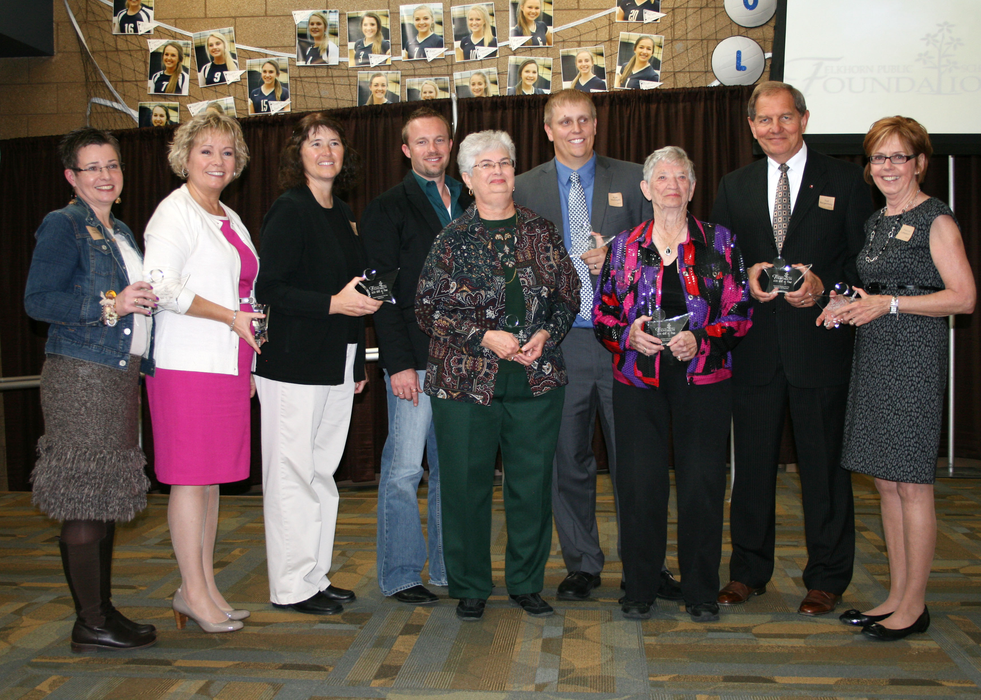

Photo #1 Caption (l-r): 2013 Hall of Fame Award Recipients: Becky Vinchur, Ann Holmes, Valerie Haase, Ronnie Rothe, Patsy Schmidt, Kyle McCright, Maxine Lenhart, Tod Ringenberg, and Patricia Lotspeich.



Photo #2 Caption: Middle School & High School representatives accepting their Classroom Grant Checks at the Hall of Fame Reception (l-r) Jodi Klein, Deb Garrison, Chad Soupir, Dan Radicia, and Mark Kalvoda.



Photo #3 Caption: Elementary School Principals accepting their Classroom Grant Checks at the Hall of Fame Reception (l-r) Troy Sidders, Andy Luebbe, Pam Wahl, Jen Coltvet, Laurinda Petersen, Jan Peterson, Amy Christ, Deb Madden, and Anne Doerr.

