20214 VETERANS DRIVE, STE. 400 • ELKHORN, NE 68022
PRESS RELEASE
PRESS RELEASE
Contact: Stacey L. Falk, Executive Director FOR IMMEDIATE RELEASE
Elkhorn Public Schools Foundation October 30, 2017
402-289-1727 • sfalk@epsne.org
www.elkhornfoundation.org

ELKHORN PUBLIC SCHOOLS FOUNDATION HOSTS HALL OF FAME RECEPTION & AWARDS CEREMONY

Elkhorn, NE - Over 200 guests attended the 23rd Annual Elkhorn Public Schools Foundation Hall of Fame Reception at Elkhorn South High School on Sunday, October 23rd. A total of 9 educators, support staff members, volunteers, alumni, and community boosters were inducted into the Hall of Fame. Mayor Jean Stothert welcomed guests and led the Pledge of Allegiance. The reception featured Elkhorn High School’s Jazz ensemble providing pre-event music and Elkhorn High School musical cast members of Seussical the Musical shared their talents and provided a sneak peek of their November production. An appetizer buffet and assorted desserts were enjoyed by guests. The fall theme set the tone with large soft white pumpkins filled with an assortment of fall flowers adorning the tables, along with pictures of Elkhorn students enjoying many Classroom Grants in action! “It was a beautiful fall day as we celebrated with Elkhorn families of all ages, honoring so many deserving recipients. The many accomplishments shared about each recipient and the supportive guests in attendance was a testament to the amazing Elkhorn community we live in and the outstanding Elkhorn Public Schools family,” said Stacey Falk, Executive Director of the Elkhorn Public Schools Foundation.

During the Awards Ceremony, the Foundation inducted 9 members into its Hall of Fame. The Carl L. White Outstanding Educator of the Year, presented to an outstanding administrator or teacher who has been with the district more than 5 years, was awarded to Laura Seyl. Laura has spent the majority of her teaching career with Elkhorn Public Schools, currently teaching second grade at Spring Ridge Elementary. Jodi Schendt of Popperista Gourmet Popcorn was recognized as the Community Booster of the Year. Popperista has worked closely with various after school programs, summer leagues and school productions in the Elkhorn Public School District. Former Educator of the Year was awarded to Dr. Dennis Flood who was with the Elkhorn Public School District for 30 years, teaching and serving as Director of Special Services. Julie Mahloch, Elkhorn High School Class of 1987, and Doug Nielsen, Elkhorn High School Class of 1986, were recognized as the Alumni of the Year for their successful entrepreneur endeavors in the Omaha community.

Kendra Smith (Fire Ridge Elementary) was honored as the Golden Apple Outstanding Educator of the Year. This award is granted to an outstanding administrator or teacher who has been with the Elkhorn Public Schools District for five years or less. The Partners in Education Mentor of the Year award was presented to Patti Franz who has made notable differences in the education and life experiences of Elkhorn students. Steven Smith was awarded the Support Staff Member of the Year for his dedicated effort as Head Custodian at Arbor View Elementary School. Tom Scott was recognized as Volunteer of the Year for his 14 years of volunteering and positive contributions to Elkhorn High School’s Power Drive Team.

On behalf of the Foundation, Stacey Falk awarded a check to the Elkhorn Public Schools District for over $166,000 for classroom grants. Each school will receive a customized version of this check showing the amount awarded to that school and a listing of the businesses, families, and fundraisers that donated to the Grant A Wish campaign.

If you would like more information about how to nominate individuals for the Foundation’s Hall of Fame, or how to contribute to the Foundation’s many programs, please contact Stacey Falk at 402.289.1727.

# # #

Photo #1 Caption: 2017 Hall of Fame Award Recipients (l-r): Patti Franz, Steven Smith, Tom Scott, Kendra Smith, Laura Seyl, Jodi Schendt, Julie Mahloch and Doug Nielsen. Not pictured Dr. Dennis Flood.

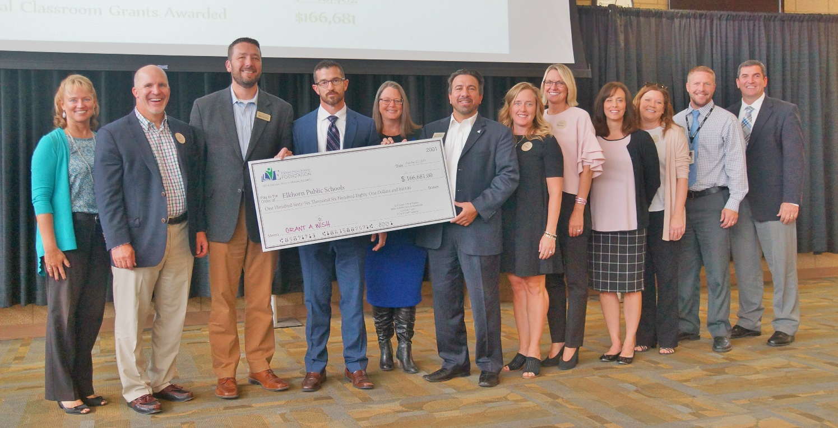

Photo #2 Caption: Elkhorn Public Schools representatives accepted a check for $166,000 for classroom grants from the Foundation at the Hall of Fame Reception. Each school will display a check highlighting the amount received and thanking their donors. Pictured above are Laurinda Petersen (Spring Ridge Elementary), Chad Soupir (Elkhorn Valley View Middle School), Mark Kalvoda (Elkhorn South High School), Troy Sidders (Arbor View Elementary), Deb Garrison (Elkhorn Middle School), Dan Radicia (Elkhorn High School), Jen Coltvet (West Bay Elementary), Jan Peterson (Sagewood Elementary), Pam Wahl (West Dodge Station Elementary), Deb Madden (Hillrise Elementary), Andy Luebbe (Skyline Elementary) and Mike Tomjack (Elkhorn Grandview Middle School).

