20214 VETERANS DRIVE, STE. 400 • ELKHORN, NE 68022
PRESS RELEASE
PRESS RELEASE
Contact: Stacey L. Falk, Executive Director FOR IMMEDIATE RELEASE
Elkhorn Public Schools Foundation October 27, 2016
402-289-1727 • sfalk@epsne.org
www.elkhornfoundation.org

ELKHORN PUBLIC SCHOOLS FOUNDATION HOSTS HALL OF FAME RECEPTION & AWARDS CEREMONY

Elkhorn, NE - Over 250 guests attended the 22nd Annual Elkhorn Public Schools Foundation Hall of Fame Reception at Elkhorn South High School on October 23rd. A total of 10 educators, support staff members, volunteers, alumni, and community boosters were inducted into the Hall of Fame. Mayor Jean Stothert led the Pledge of Allegiance for the guests. The event featured Elkhorn High School’s Brass ensemble playing tunes during the reception and Elkhorn High School musical cast members of Guys & Dolls shared their talents and provided a sneak peek of their November production. An appetizer buffet and desserts were enjoyed by guests. The autumn theme set the tone with large soft white pumpkins filled with an assortment of fall flowers adorning the tables, along with pictures of Elkhorn students enjoying many Classroom Grants in action! “This event is a highlight of our year; it’s a time to celebrate the accomplishments and honor some outstanding individuals who have positively represented and impacted the Elkhorn community,” said Stacey Falk, Executive Director of the Elkhorn Public Schools Foundation.

During the Awards Ceremony, the Foundation inducted 10 members into its Hall of Fame. The Carl L. White Outstanding Educator of the Year, presented to an administrator or teacher who has been with the district more than 5 years, was awarded to Jan Brink. Jan has spent 16 year teaching special education in the Elkhorn Public School district, with the last 3 years at West Bay Elementary School. Ed & Julie Pullen of CCS Presentation Systems were recognized as the Community Booster of the Year. CCS has worked closely with the Elkhorn Public School District on providing the latest in classroom technology to provide teachers and students the best possible learning environment. Former Educator of the Year was awarded to Julie Jones who taught for 28 years in the district at Skyline and Hillrise Elementary Schools. Dr. Mike Feilmeier, Elkhorn High School Class of 1997, was recognized as the Alumnus of the Year for his dedicated effort to see that no one lives needlessly in darkness.

Jessica Ethridge (Spring Ridge Elementary) and Julie Feldman (West Bay Elementary) were honored as the Golden Apple Outstanding Educators of the Year. This award is granted to an outstanding administrator or teacher who has been with the Elkhorn Public Schools District for five years or less. The Partners in Education Mentors of the Year award were presented to Liz Fogle and Cindy Hulsebus who have made notable differences in the education and life experiences of Elkhorn students at West Bay and Fire Ridge Elementary Schools. George Roshone was awarded the Support Staff Member of the Year for his dedicated effort as Head Custodian of Fire Ridge Elementary School. Theresa Johnson Was recognized as Volunteer of the Year for her significant and positive contributions to Elkhorn students.

On behalf of the Foundation, Stacey Falk awarded a check to the Elkhorn Public Schools District for over $119,000 for classroom grants. Each school will receive a customized version of this check showing the amount awarded to that school and a listing of the businesses, families, and fundraisers that donated to the Grant A Wish campaign.

If you would like more information about the Elkhorn Public Schools Foundation, would like to nominate someone for an award, or find out how to contribute to the Foundation’s many programs, please contact Stacey Falk at 402.289.1727.

# # #

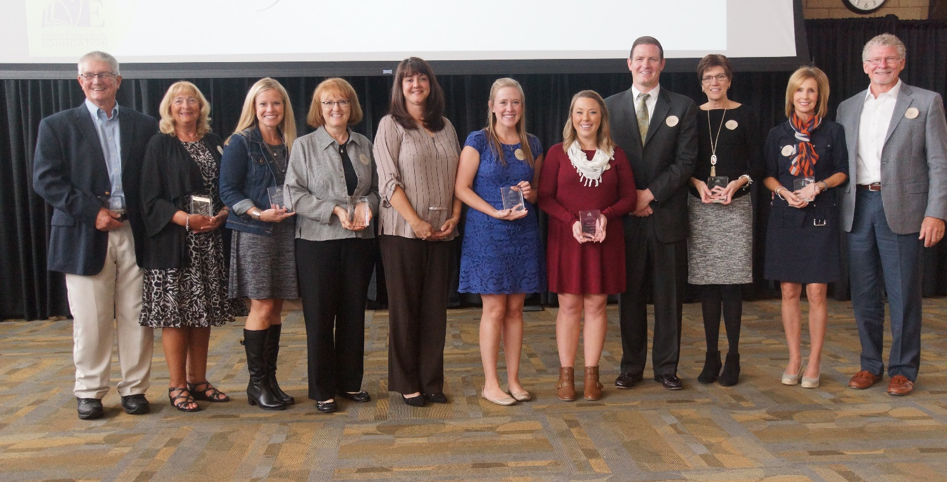

Photo #1 Caption: 2016 Hall of Fame Award Recipients (l-r): George Roshone, Julie Jones, Liz Fogle, Cindy Hulsebus, Theresa Johnson, Julie Feldman, Jessica Ethridge, Dr. Mike Feilmeier, Jan Brink, Julie Pullen and Ed Pullen.

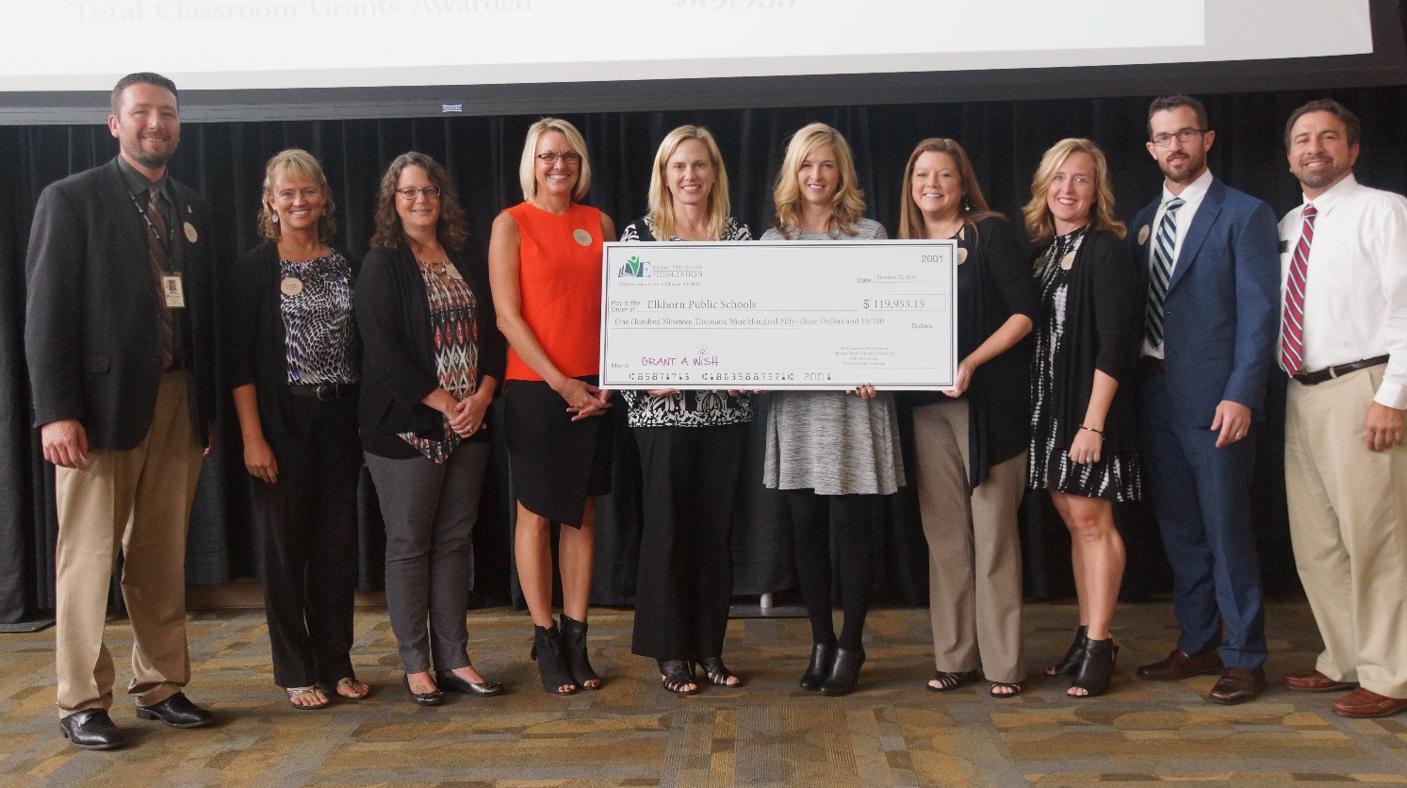

Photo #2 Caption: Elkhorn Public Schools representatives accepting the Classroom Grant check for $119,000 at the Hall of Fame Reception. Each school will also display a check highlighting the amount received and thanking their donors. Pictured above are Mark Kalvoda (Elkhorn South High School), Laurinda Petersen (Spring Ridge Elementary), Deb Garrison (Elkhorn Middle School), Jan Peterson (Sagewood Elementary), Amy Christ (Manchester Elementary), Deborah Knutson (Fire Ridge Elementary), Deb Madden (Hillrise Elementary), Jen Coltvet (West Bay Elementary), Troy Sidders (Arbor View Elementary), and Dan Radicia (Elkhorn High School).

