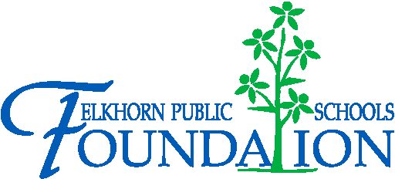

20214 VETERANS DRIVE, STE. 400 • ELKHORN, NE 68022
PRESS RELEASE
PRESS RELEASE
Contact: Stacey L. Falk, Executive Director FOR IMMEDIATE RELEASE
Elkhorn Public Schools Foundation July 09, 2015
402-289-1727 • sfalk@epsne.org
www.elkhornfoundation.org

Elkhorn Public Schools Foundation raises over $27,000 for the Classroom Grant Program at its 16th Annual “Golf Fore Grants” Tournament

Elkhorn, NE - On Monday, June 8, 2015, over 130 golfers, volunteers & sponsors joined the fun at Shadow Ridge Country Club for the 16th annual Golf Fore Grants Tournament! This year the Golf Fore Grants event raised over 27, 000 to benefit our Classroom Grants Program which funds grants in all of the 15 schools in the Elkhorn Public School district. Grants awarded range from new technology at the elementary schools utilizing audio books, IPads, and smart projectors to Middle School author visits and Physics lab stations at the High Schools. “We are truly blessed. The generosity of our guests is absolutely amazing. The support of all of our sponsors and the dedication of our Foundation staff and volunteers is what makes this event such a success,” said Stacey Falk, Executive Director of the Elkhorn Public Schools Foundation.

The Foundation offered a morning 9-hole round which included a light breakfast, lunch and pin prizes. Tim Legband, Darren Osten, Jason Christo and Chris Chochon were the morning pin prize winners. A four person 18-hole afternoon scramble began with lunch, was followed by a noon shotgun start, and ended with a rib-eye dinner buffet. ESHS cheerleaders, Elkhorn Kids Campus, Foundation Board members, GERST Painting, Baxter Ford, Sam & Louie’s Pizza and volunteers from AXA Advisors teamed up to help with games all along the course – including opportunities to win a new Ford F-150, free pizza for a year, putting green contest and much more.

The grand finale was the awards presentation announcing flag pin prizes consisting of coolers filled with golf goodies, a poker contest, putting contest winners, raffle winner and afternoon tournament champions. Anne Doerr was the winner of the ladies silent auction golf bag. Dave Raymond, Tim Hughes, Steve Baker, and Danny Szegda were crowned “Golf Fore Grants” Tournament Champions.
The Foundation is seeking additional funding for the Classroom Grants program through the “Grant-A-Wish” campaign – enabling donors to help “grant” the Classroom Grant wishes of our teachers and school administrators. If you would like to support the Elkhorn Public Schools Foundation or find out more about classroom grants, contact Stacey Falk at (402) 289-1727 or visit www.elkhornfoundation.org.

-END-

