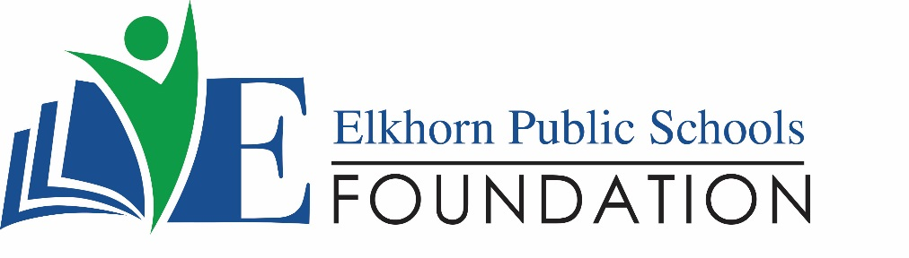

20214 VETERANS DRIVE, STE. 400 • ELKHORN, NE 68022
PRESS RELEASE
PRESS RELEASE
Contact: Stacey L. Falk, Executive Director FOR IMMEDIATE RELEASE
Elkhorn Public Schools Foundation May 19, 2017
402-289-1727 • sfalk@epsne.org
www.elkhornfoundation.org

Elkhorn Public Schools Foundation RaiseS $33,000+ at Bids 4 Kids Fundraiser

Elkhorn, NE - The Elkhorn Public Schools Foundation hosted the 5th Annual Bids 4 Kids Ladies Night Out on April 6, 2017, at Noah’s Event Venue. With over 200 guests in attendance, the community event raised close to $33,000 to help fund the Foundation’s Math and Reading Intervention programs at all 10 elementary schools in the Elkhorn Public School District.

The event featured a silent auction, raffles, complimentary appetizers and desserts. To ensure that all patrons had the best silent auction experience at this year’s event, the Foundation utilized a mobile bidding platform through Qtego Auctions. This software allowed over 350 community members to bid on their favorite silent auction items through their mobile device, whether at the event or remotely. Over 200 local businesses and community partners donated auction items, food and raffle prizes and helped sponsor the event. Each school in the district donated school experiences and sports camps for students and their families. The top raffle prize at this year’s event was a Hy-Vee Fill Your Cart shopping experience. Access Bank sponsored this raffle prize and 90 seconds of shopping happened at the local 156th & Maple Hy-Vee location on Wednesday, May 10th. This year’s winner, Lindsay Scott, received $505.00 in groceries!

“We are delighted at the success of this year’s Bids 4 Kids event!” said Executive Director Stacey Falk. “We had a record year and it can all be attributed back to the generosity of our donors, volunteer support, attendees and auction participants. The proceeds are directly going back into our elementary schools to help those students in our Math & Reading Intervention Program. It is truly amazing to see the outpouring of support we have for our EPS students and educational programs. Thank you to everyone who was a part of our annual ladies event!”

To view photos from the 2017 Bids 4 Kids event, or to learn more about upcoming Foundation events, please visit www.elkhornfoundation.org.
# # #

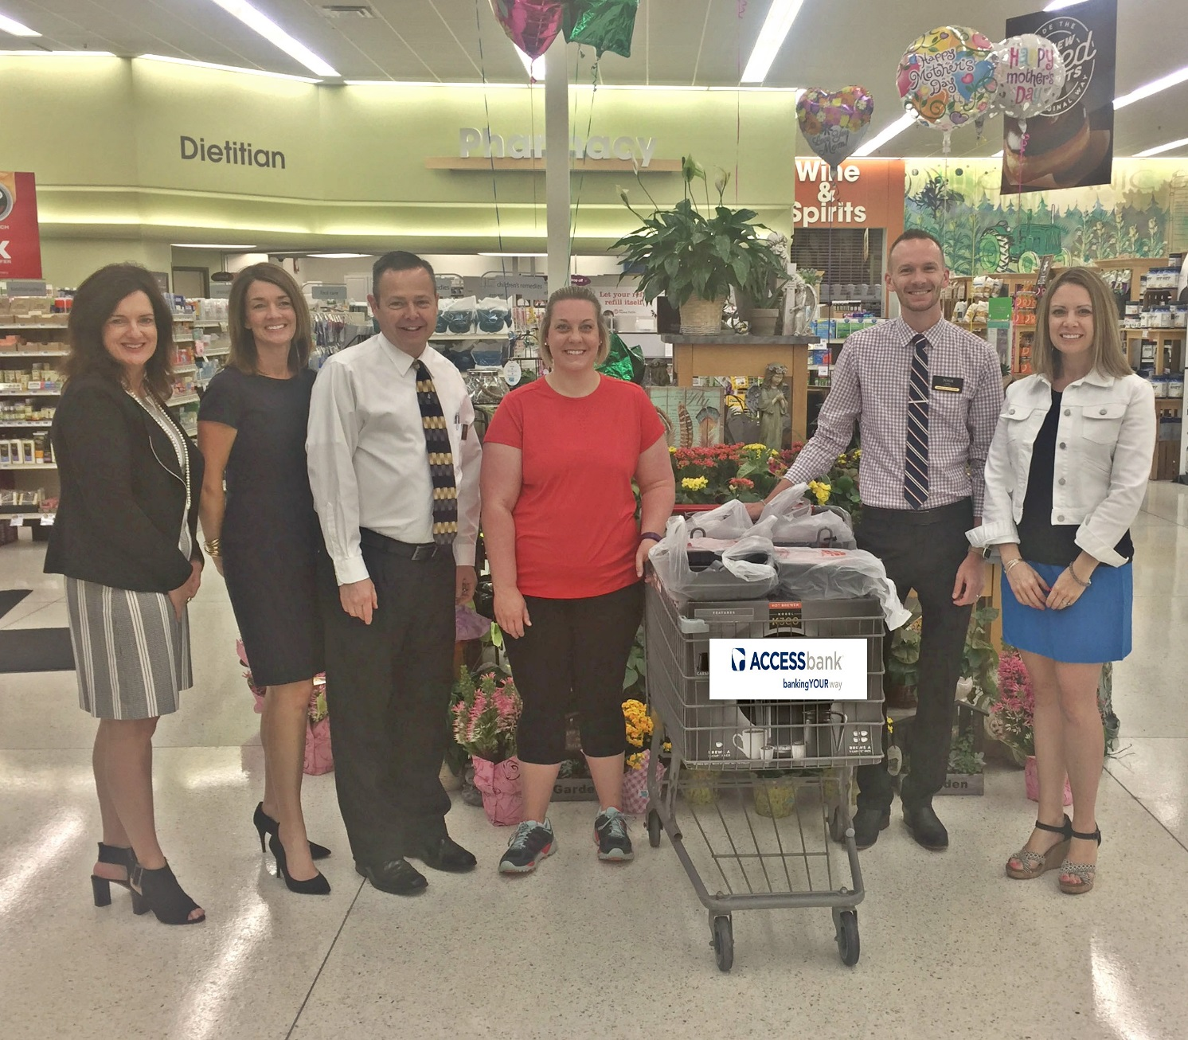

Photo #1 Caption: Lindsay Scott, winner of the Elkhorn Public School Foundation’s top raffle prize at the 2017 Bids 4 Kids event, claimed her 90 Second Hy-Vee Shopping Experience on May 10th. The Foundation partnered with Hy-Vee on 156th & West Maple Road, and Access Bank sponsored this prize. Lindsay had 90 seconds to fill her cart, limited to only two per item, and was able to snag up $505 in groceries. Featured are (l-r): Stacey L. Falk (Executive Director EPSF), Laurie Cradick (Access Bank), Jim Ewoldt (Hy-Vee Store Director), Lindsay Scott, Josh Long (Hy-Vee Store Manager) and Stacey Selk (Marketing & Events Manager EPSF).

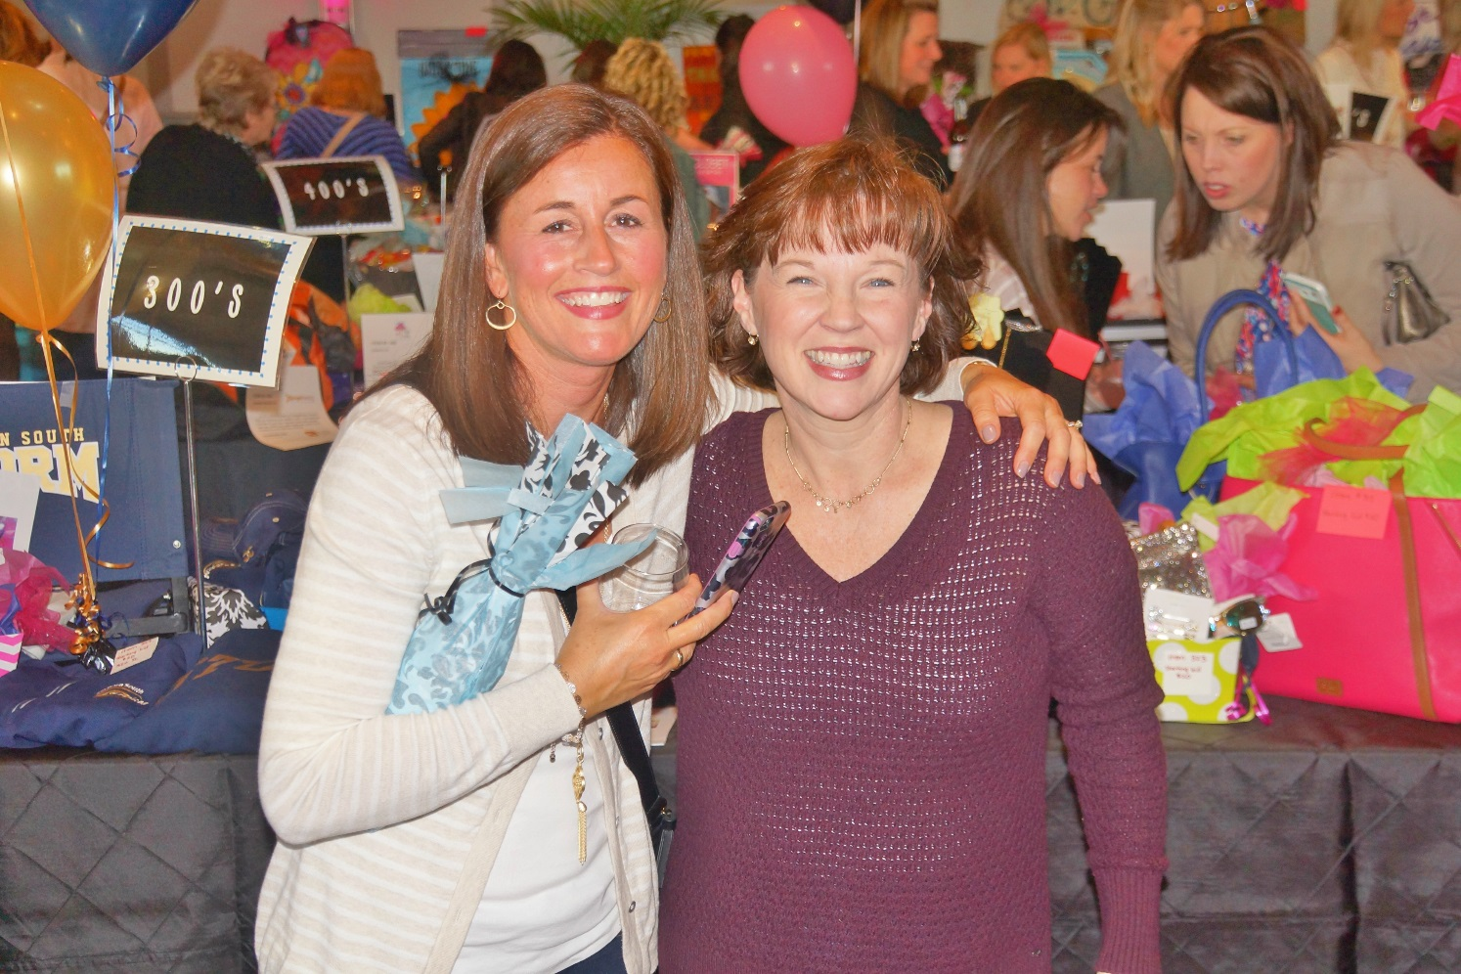

Photo #2 Caption: Jenny Haase and Christy Clement, committee volunteers for the 5th Annual Bids 4 Kids Event, pose during the 5th Annual Bids 4 Kids Event. The Foundation utilized a mobile bidding platform, allowing over 350 community members to bid on silent auction packages at the event or remotely.

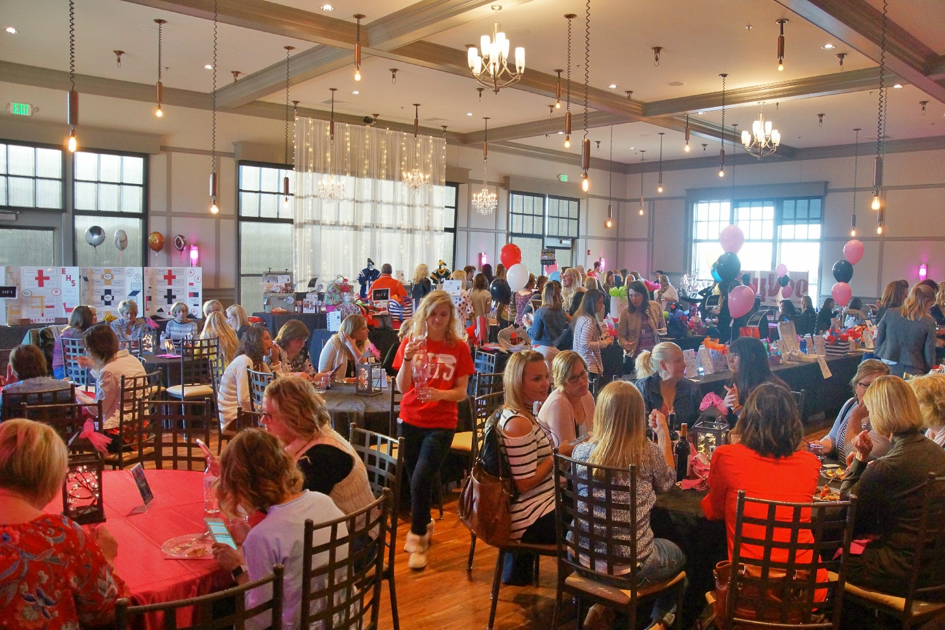
Photo #3 Caption: Over 200 guests attended the 5th Annual Bids 4 Kids event on April 6th at Noah’s Event Venue. Proceeds from the event benefit the Elkhorn Public School Foundation’s Math & Reading Intervention Programs held in all 10 elementary schools in the Elkhorn Public School District.

-END-

