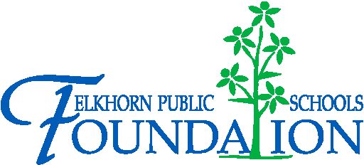

20214 VETERANS DRIVE, STE. 400 • ELKHORN, NE 68022
PRESS RELEASE
PRESS RELEASE
Contact: Stacey L. Falk, Executive Director FOR IMMEDIATE RELEASE
Elkhorn Public Schools Foundation April 17, 2015
402-289-1727 • sfalk@epsne.org
www.elkhornfoundation.org

Elkhorn Public Schools Foundation Raised $16,000+ at Bids 4 Kids Fundraiser

Elkhorn, NE - The Elkhorn Public Schools Foundation hosted the third annual Bids 4 Kids Ladies’ Night Out on April 9, 2015, at The Ridge banquet facility in Elkhorn, Neb. The community event raised more than $16,000 to help fund reading and math intervention programs at all nine elementary schools in the Elkhorn Public Schools district.

The event featured a silent auction, raffles, complimentary appetizers and a cash bar. Hundreds of local businesses and community partners donated auction items, food and raffle prizes. Each school in the district donated school experiences and sports camps for students and their families.

“Bids 4 Kids is a success because of the generosity of donors, volunteers and attendees in and around the Elkhorn community,” said Executive Director Stacey Falk. “It is amazing to see the outpouring of support for area students and educational programs through Foundation events like Bids 4 Kids. Thank you to everyone who was a part of this great event!”

To view photos from the 2015 Bids 4 Kids event, or to learn more about upcoming Foundation events, please visit www.elkhornfoundation.org.

-END-

