ELKHORN PUBLIC SCHOOLS FOUNDATION HOSTS
15th ANNUAL “GOLF FORE GRANTS TOURNAMENT”

Elkhorn, NE: June 20, 2014

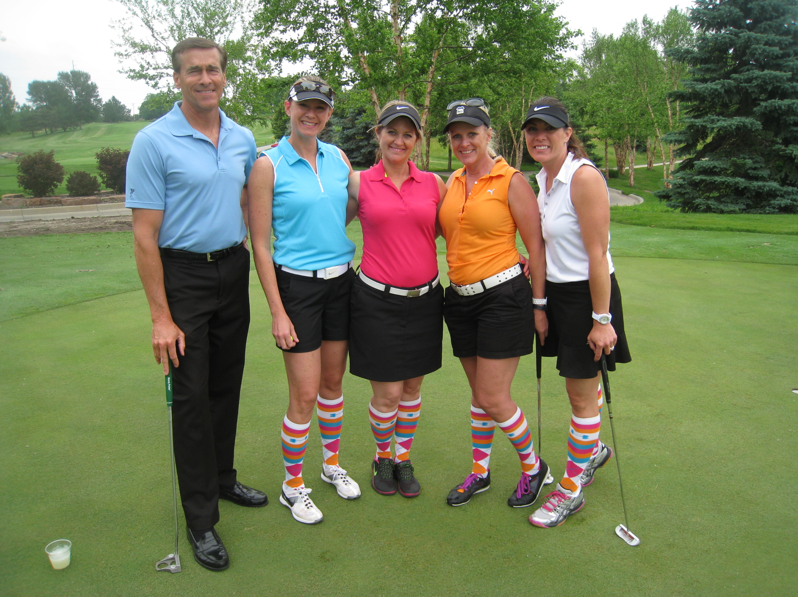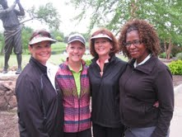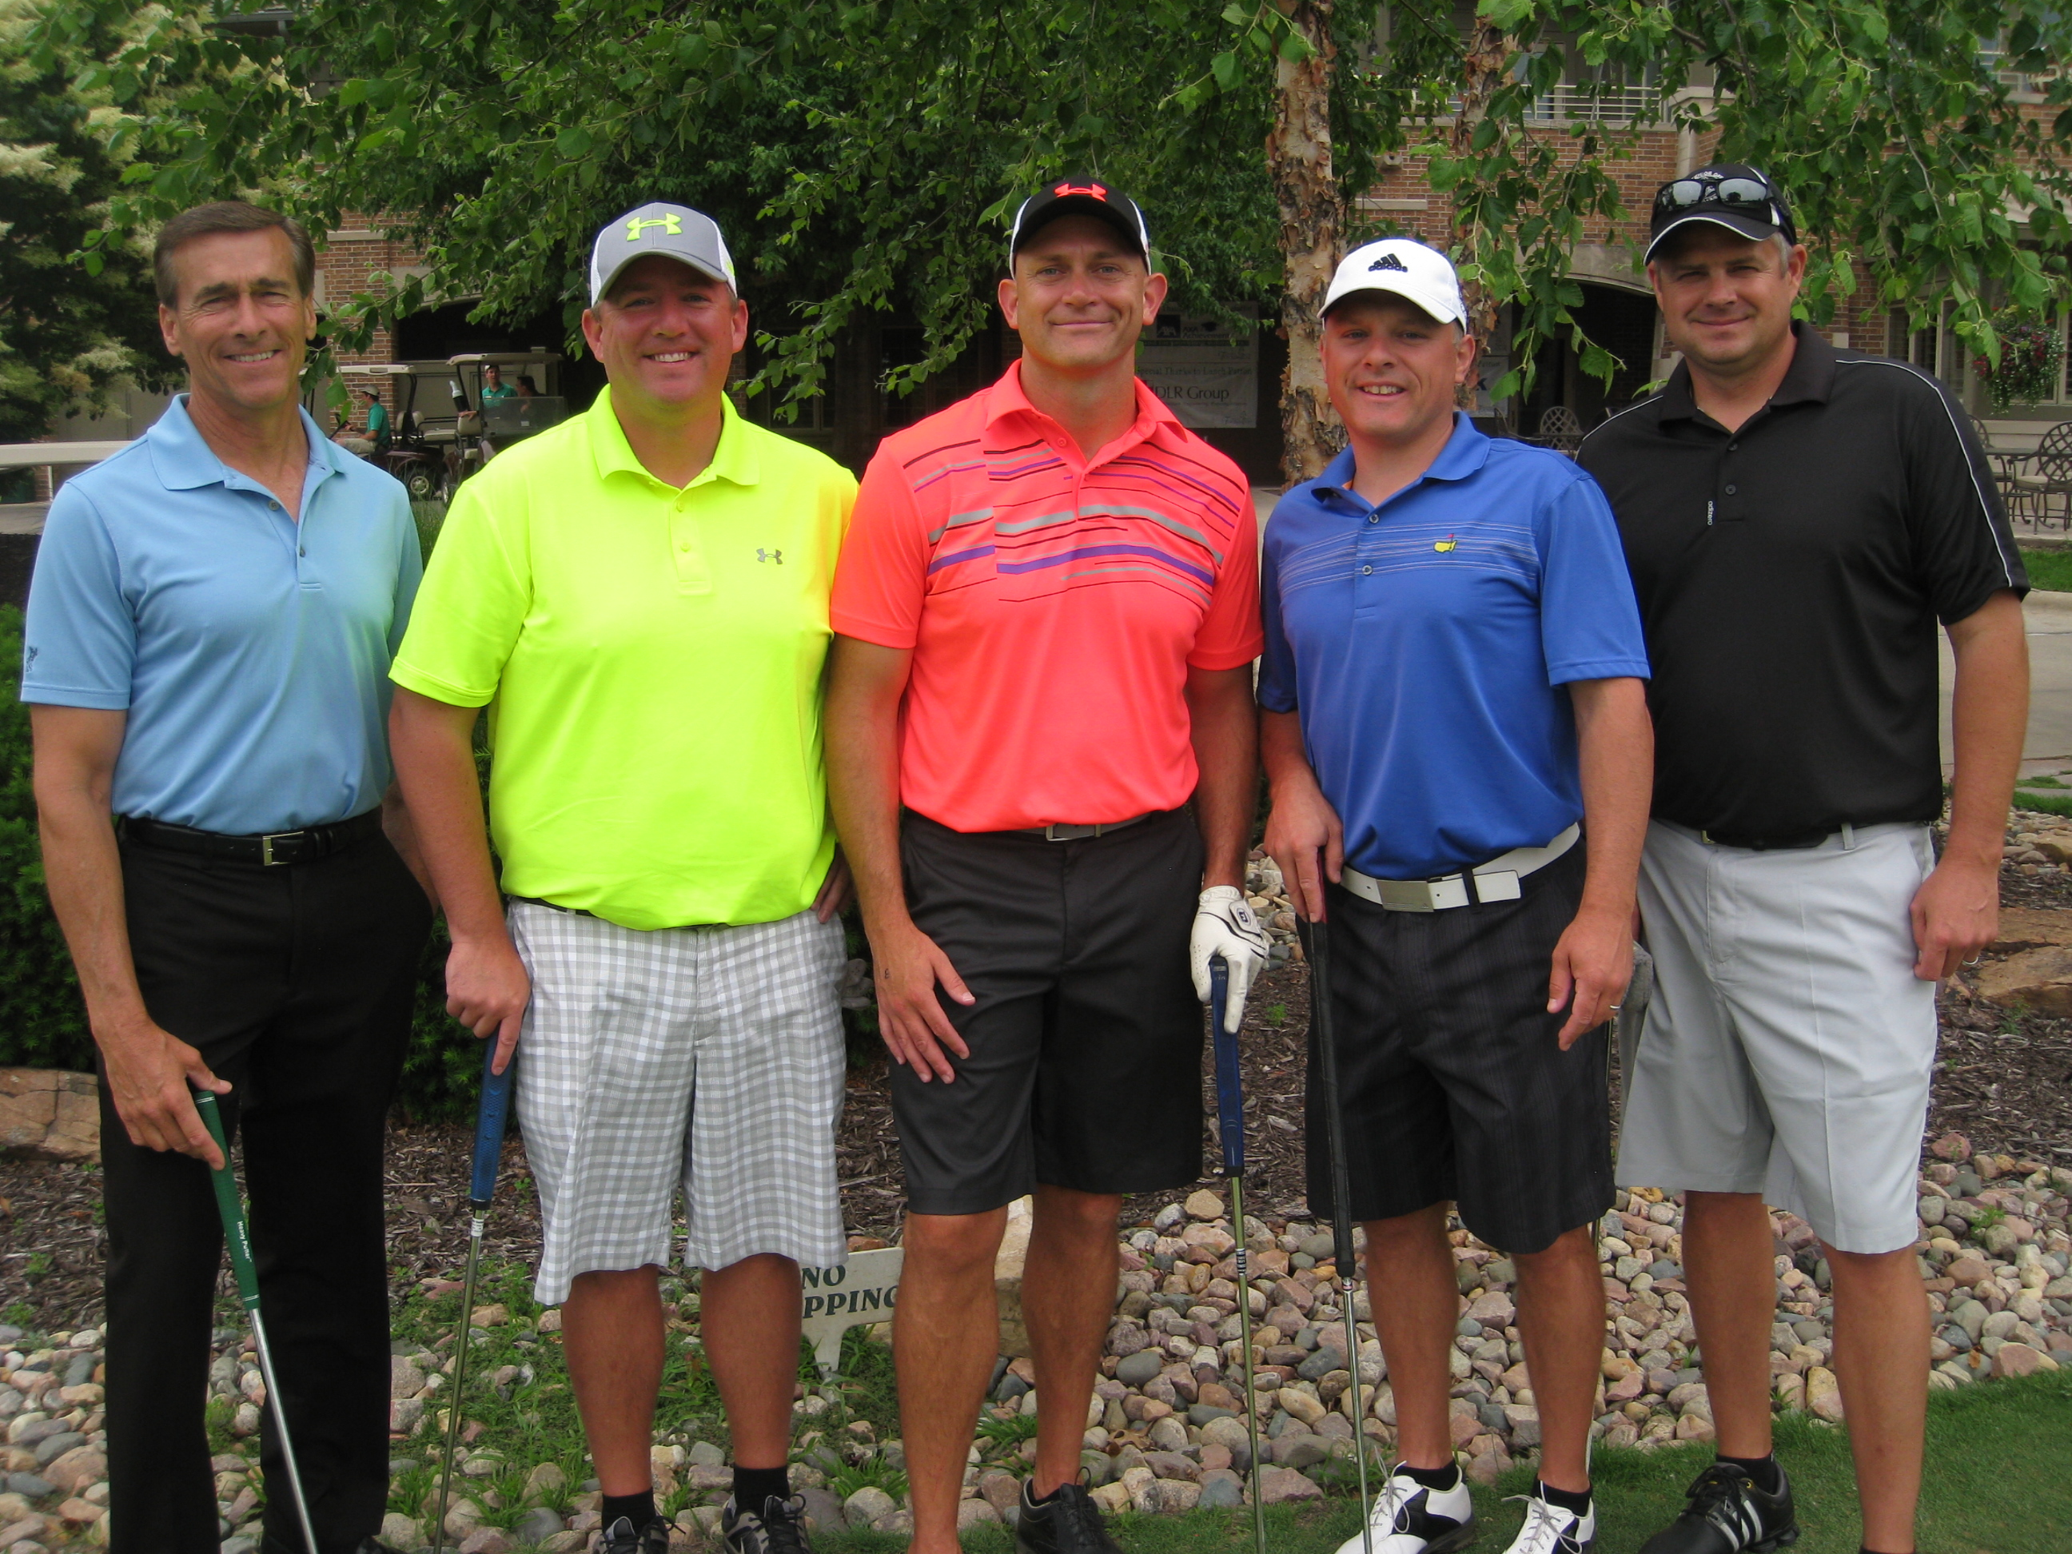

One hundred and fifty-six golfers teed off in support of Elkhorn Public Schools students and teachers on Monday, June 9th at Shadow Ridge Country Club. The 15th Annual Golf Fore Grants Tournament raised $26,500 to help fund classroom grants ranging from new technology for the Special Education Department, a summer school baseball field trip, and Circle of Friends autism curriculum to 3rd Grade wax museums, book rooms, smart projectors, cameras, and so much more. Over $130,000 in classroom grants will be awarded across all 15 schools within the Elkhorn Public Schools District this year. “At the Foundation, we believe in the potential of every student and are proud to be able to provide enrichment for our students and teachers at all grade levels,” stated Stacey Falk, Executive Director of the Elkhorn Public Schools Foundation. She continued, “We are honored by the investment and time that our volunteers, sponsors and golfers shared with us today. Thank you for helping us fulfill our mission of encouraging and supporting excellence in innovative education and school programs.”

New this year, the Foundation offered a morning 9-hole round which included a light breakfast, lunch and encouragement on the course from the Elkhorn South High School cheerleaders. Matt Kirkland, Chris Morris, Doug Nodgaard, and Greg Crawford were the morning round victors. A four-person 18-hole afternoon scramble began with lunch, was followed by a noon shotgun start, and ended with a rib–eye dinner buffet. ESHS cheerleaders, Elkhorn Kids Campus, Foundation Board members, GERST Painting, Huber Cadillac, John Knicely from WOWT News, Sam & Louie’s Pizza and volunteers from AXA Advisors teamed up to help with games all along the course – including opportunities to win a new Cadillac, free pizza for a year, a “Putting with John Knicely” contest, and more.

The grand finale was the awards presentation announcing flag prizes, poker contest winners, putting contest winners, raffle winner, and afternoon tournament champions. Jason Bartling, Robert Deleidi, Andy Knutson, and Erich Meyer were crowned Golf Fore Grants Tournament Champions this year ending a three-year winning streak by Steve Baker, David Raymond, Danny Szgeda and Tim Hughes.

The Foundation is seeking additional funding for the Classroom Grants program through the “Grant-A-Wish” campaign – enabling donors to help “grant” the Classroom Grant wishes of our teachers and school administrators. If you would like to support the Elkhorn Public Schools Foundation or find out more about classroom grants, contact Stacey Falk at (402) 289-1727 or visit www.elkhornfoundation.org.

